**Project information**

Donor/Contractor:

**IFAD/MAIL**

Period:

**10 May 2021 – 31 Dec 2021**

Area:

**6 Provinces**

**Rural Poor Stimulus Facility (RPSF-1)- Afghanistan**

**Goal and Objectives:** The goal of the project is to minimize the impacts of COVID-19 on livelihoods, resilience, and food security for vulnerable households in the country. The development objective of the project is to protect livestock assets, production capacity and facilitate access to markets. **Geographic Area:** The geographic area for the project will be selected in a flexible manner keeping several factors in mind. The provinces selected will include those, which are: (i) part of one of the on-going IFAD projects namely CLAP; (ii) those with a presence of both settled, semi-settled Kuchi, and some on the nomadic Kuchi migration routes; (iii) those which are the primary destinations for returnees from Iran and other COVID-19 hotspots and are at high risk of spread; (iv) those where milk production is high and problems of marketing more difficult; (v) proximity to ensure that the project is delivered efficiently and cost-effectively within a concentrated area.

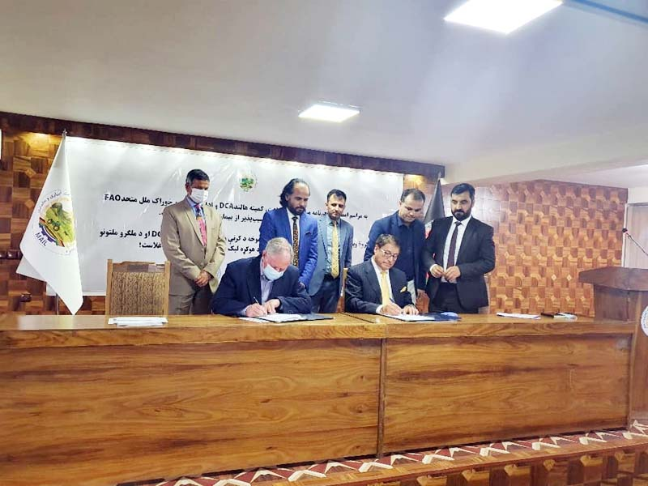

**Livestock protection package:**

To avoid distress sale of animals, especially for the most vulnerable households who might not be able to sustain their herds because of reduction in income or access to natural resources and feed markets, the project will provide feed resources for the winter season in which feed shortage is the most acute. The package will be constituted in a flexible manner keeping in mind the needs of the target group and their specific livelihood pattern. Each household (4,000 Households targeted) will be given 100 kg of concentrate feed, which is sufficient for the average vulnerable household’s flock of small ruminants, inputs for lamb fattening, deworming medicine, and animal nutrition advice.

**Veterinary services:**

FAO and DCA have developed and refined a method for using COVID-safety measures and in collaboration with VFUs continue to provide livestock veterinary / animal extension services and inputs to small-herders.  This service provision follows strict protocols developed by FAO that adopt COVID-safety practices of physical distancing, sanitation, use of COVID-PPE, and are done in a staggered manner to avoid concentration of herders and minimize the risk of COVID-19 transmission.  The service providers and participants are provided Physical Protective Equipment (PPE). The training also provides awareness to the *Kuchi* on adoption of COVID-safety practices at household, farm/cattle shed, herd-management and livestock market-participation levels (6,300 Individuals in 180 groups targeted).