Project information
Donor/Contractor:

PUR Development Pte. Ltd.
Period:

February 2018 – April 2022
Area:

Herat and Balkh provinces

PUR Project – Breeding Program
On 16th of February 2018, DCA Livestock Programs and PUR Development Pte. Ltd. signed a 4-year contract for the design and implementation of a breeding program in Afghanistan. This project is part of a bigger project which is implemented by Oxfam and PRB, and DCA is part of the whole Project Management Unit.

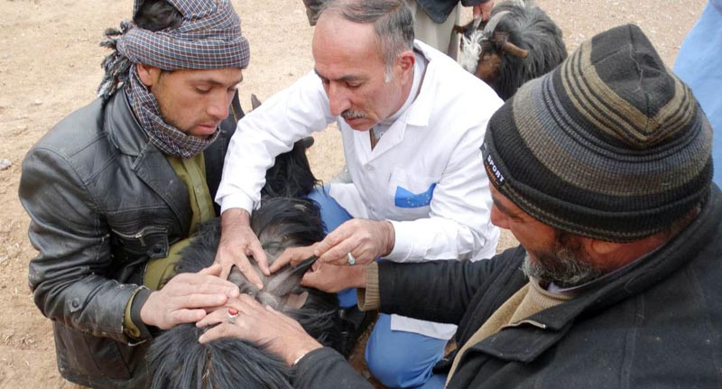
The aim of the breeding program is to support goat herding communities involved in the cashmere value chain in Afghanistan by introducing high quality cashmere goats in Herat and Balkh provinces. A team of DCA staff will assist, develop, and monitor a Centralized Elite Flock of cashmere goats in Herat province in order to selectively breed high quality goats with improved cashmere quality, dairy and meat production traits.
DCA will be responsible for the distribution of these high-quality bucks to 20 Elite Sub-Flocks to be created through socialization in collaboration with the National Partner at village level in Herat and Balkh provinces. Bucks from the Elite Sub-Flocks will be used for mating with females from other flocks in the villages to spread improved genetic material amongst cashmere goat populations in these areas.

