Hard Work Trade-off (Feeling Accountable)
Introduction:
To be transparent and accountable against all the staffs being performed under CLAP-KUCI PROJECT; DCA has always been undertaking different approaches to reach to its stakeholders against the project progress. Thus, one of the most successful approaches, that DCA use to report and coordinate with its stakeholders is establishing Kuchi board on village, districts and provincial level. So that on 25th –Dec- 2019 DCA/CLAP-Kuchi project organized a provincial multi-stakeholder Kuchi board event in GENERAL DIRECTORATE of KUCHI’s Kabul, Afghanistan.
Objective of Kuchi Board Meetings:
The aims of organizing and establishing such a Shuras and Events, are to share the project plan and achievements with the different stakeholders and representatives of pastoralists and agro- pastoralists’ kuchi twice in a year, to contribute their support and assistance in implementation of the project and to discuss the challenges that the Kuchi are straggling with. Identify key lessons for future planning and disseminate best practices with different stakeholders.
Key findings:
Different stakeholders (220 people) from Logar, Kabul, Parwan, Baghlan, and Balkh provinces, (Provincial Kuchi Directorate Officials), government officials (Parliament Members, Mushrano Jirga members, and Deputy Minister to the Tribe and Border Affairs), farmers and project provincial coordinators and facilitators were invited to the event. So that the event around 10:30 am officially started by the recitation of some verses of Quraan Karim and national anthem. The event covered by some well-known public media such as (Meli TV,) as well.
The event had two parts; 1. General disccussion 2. Kuchi products exhibition.
Taking the opportunity, Mr. Dr, Faridoon Quami as the CLAP-Kuchi project manager, had a brief discussion on project achievement, rule of Kuchi’s in development of Afghanistan’s national and international economy, challenges that the Kuchis are straggling with all around the country. He adds, that implementing such a small project to those who own all most 60-70% of the country small ruminants with them is nothing, but needs more and more (24/7 hours) work and more funds to come up with the problems that Kuchis as livestock keepers are in trouble.
As a fortunate event than the past relevant experiences. In this event high officials from the government were present, and so on behalf of them, following Dr. Faridoon Qaumi the deputy minister of tribe and border affairs Mr. Faraidon Barakzai had a short speech about the Kuchi challenges, importance of the CLAP-Kuchi project, rules of Kuchis in socio-economic development and promised that they would fully support the Kuchis in all parts of socio-developments.
After on, the head of Kuchi’s general directorate Mr. Ustab Habiburahman Ahmadzai as one of the key stakeholder that has a significant influence on presenting CLAP-Kuchi to the government ,even to the president of Afghanistan, started his speech by well coming the audience and expressing his sincere appreciation to the DCA/CLAP-Kuchi project by what they have been performing, doing and serving to the Kuchi, who were really for from the very mini but valuable things, that they are receiving now through CLAP-Kuchi project, that’s being implemented by DCA, in terms of inputs, training Para-Vet from their communities, establishing VFUs and Fodder Banks and provision of high quality veterinary services.
He called Kuchis as the back-bone to the development of Afghanistan economy, the rules that the Kuchi plays in Afghanistan’s economy and social-welfare. He adds, that they would strongly support the DCA and will officially meet the relevant project’s influencer in order to nation-wide this crucial project, which has always been showing visible changes among the Kuchi communities.
At the end he once again he honored the DCA/CLAP-Kuchi project staffs, appreciated them, wishes them all the success in the futures, and offered an appreciation letter to the CLAP-Kuchi project manager, for all their tireless efforts and work they have done for the Kuchis within the targeted provinces.
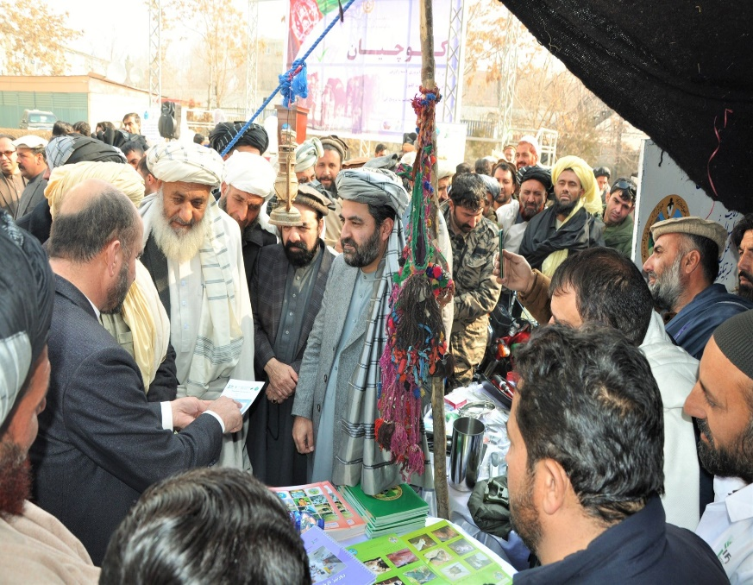
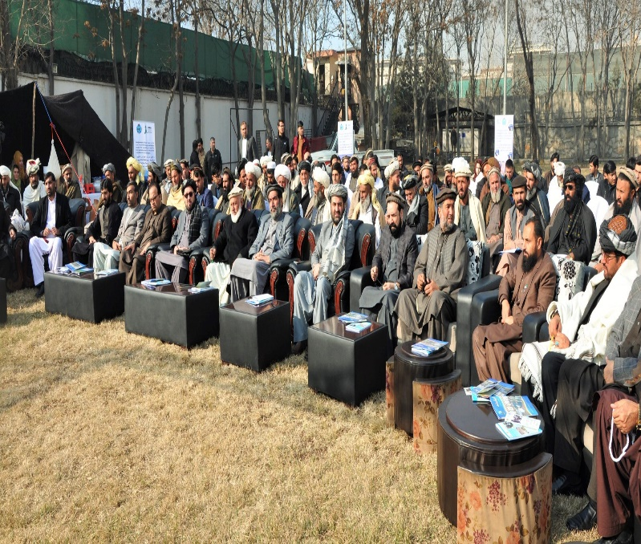
Finally, the event officially closed after the exhibition of Kuchis’ products, sharing best practices to the government officials, key stakeholders and farmers.
