Alternative Development Programme
Boost Alternative Development Intervention through Licit Livelihoods (BADILL)
Period covered: December 1, 2017- December 31, 2020
- Summary

Project/Sub-programme Number
Title | Boost Alternative Development Intervention through Licit Livelihoods (BADILL)
Duration (years/months) | 37 months including 5 months no cost extension
Starting Date (Afghanistan segment only) | 1st Dec 2017
Location(s) | In total 17 locations of the following provinces.  Maidan-Wardak (Districts – Maidan-Shar, Behsood 1 and Markaz-e- Behsood)  Parwan (Districts - Bagram, Salang and Charikar)  Panjshir (Districts – Unaba, Rokh, and Shutol)  Bamyan (Districts – Bamyan Center, Yakawlang, Yakawlang 2, Panjab, Shibar, and Saighan )  Kabul (District – Sorobi)  Kapisa (District – Tagab)
Responsible Office: | UNODC Country office – Afghanistan
UNODC Regional / Country or Thematic Programme Outcome to which this program/project directly contributes
Executing Agency | Dutch Committee for Afghanistan (DCA)
Government Implementing Agency/Partners | National Alternative Development Agencies (MAIL, MCN, MRRD, and MoWA)
UNODC Overall Budget | USD 1,864,765
Donor(s) | UNODC

Executive summary

This report provides a progress update on the UNODC-founded “Boost Alternative Development Intervention through Licit Livelihoods (BADILL)”, for the period December 1, 2017, to December 31, 2020. The program makes sectoral interventions in three components. Those being animal husbandry, backyard poultry farming, and kitchen gardening. It, furthermore, addresses the cross-cutting themes of gender. The program is being implemented in Kabul, Kapisa, Parwan, Panjshir, Wardak, and Bamyan provinces.
The project potential stakeholders, mainly the PAIL, economics department, communities, and field monitors facilitated in joint monitoring missions for further collaboration, and successful implementation of the project targeted activities and inputs.
5,000 direct (4572female and428male) and 30,000 indirect beneficiaries benefited from the project through individual and community-based interventions (The project community-based intervention/services not only remain limited to project direct beneficiaries. Other communities also benefited from VFU, MCC, breed improvement and feed bank services. Furthermore, the non-selected farming households participating in demonstration and training practices and more recently 4,000 HHs covered under COVID-19 awareness campaign. These activities have been successful in enhancing the income from the licit livelihoods, and awareness-raising of the households regarding drug abuse. Within a year after implementation, the combined interventions and inputs already managed to increase the income of poultry and dairy farming households by 30% to 40%. (3,204 households have managed to sell between 90 and 210 liters of surplus milk each month yielding an average monthly net income in the range of AFN 3,000 to AFN 5,000, furthermore 1700 HHs,600 provided with 30 pullets and 1,100 with 20 pullets)from the selling surplus eggs making AFN 2,460 to 4,125 net income in a monthly basis). In addition, 78 jobs have been created through local entrepreneurship by developing inputs, processing, marketing, animal health and extension services. By linking farmers to input suppliers and service providers as well as to the markets DCA has initiated the development of viable value chains from producer to consumer. By supporting the livestock farmers in these value chains, the economic growth of the community is supported. Increasing household incomes and well-being, providing employment opportunities and supporting community economic development are vital allies in preventing the rural population from becoming involved in poppy cultivation and drug use. For that reason, the project has always focused on the following objectives.

Key results:
- Awareness as a whole was increased regarding COVID-19 and Zoonotic diseases.
- Market linkages have been enhanced for both the dairy and poultry products through the establishment of Milk and Egg Collection Centers.
- Due to the established linkages between farmers and Veterinary Field Units (VFUs) the prevalence of diseases has significantly decreased. By providing comprehensive and extensive extension/training services farmers made aware of the importance of VFU services, for better management of their livestock health and production.
- Quality veterinary and breed improvement services provided by the VFUs to 4,904 households are direct beneficiaries of the project.
- By providing the backyard poultry farms with seasonal and periodic vaccination and medication, the incidence of contagious diseases has significantly decreased and a few and very limited mortality cases have reported among the distributed pullets (2-3% mortality rate).
- The 38 trained and volunteer Female Basic Veterinary Workers (FBVWs) are providing basic poultry and livestock health services with the direct effect of increasing livestock and poultry production. Due to poor farming management and practices before BADILL project farmers experienced high mortality rate among their poultry and livestock.
- 3,204 cowsheds and 1,700 modified chicken coops established by direct farmers contribution, therefor, farmers gave more attention to cowsheds and coop management resulting in improved conditions for their livestock and poultry. The intervention encouraged other villagers who are not direct project beneficiaries to copy and replicate cowsheds improvement with consulting with benefited farmers in their farms for better results and enhancement of animal health and welfare.
- Availability and accessibility to the established lucrative local markets (Milk and Egg collection centres) further persuade the direct and indirect project beneficiaries for giving more attention to their dairy products in terms of quality and quantity with more benefits from their produce and boost livelihood opportunities Both the trained MCC managers and producer farmers working together to respond the market needs considering the hygienic issues and consumer satisfaction. These interlinked endeavours opened and expanded market opportunities and encouraged small scale farmers to invest and expand their farms for more and sustainable income and livelihoods.
- Six established community-based feed banks producing quality concentrate feed for both dairy and layer poultry.
- Community-based interventions/services to ensure the adaptability and sustainability of the service delivery system in the long term.
- The established milk and egg collection centres provide good market opportunities.
- The project actively engaged in COVID-19 risk mitigation processes.

DCA BADILL Project Key achievements during the project implementation from December 1, 2017, to December 31, 2020
BADILL project aims to improve the licit livelihood options in rural areas of Afghanistan, particularly for people/areas that are at risk of starting/increasing their involvement in narcotics. These improvements took place through investment in:
- 5,000 beneficiaries (4,572 females and 428 male) trained on different topics of animal husbandry management, backyard poultry farms, and Kitchen gardening. They were organized into 384 Farmer Extension/producer Groups (FEGs) (247 livestock extension groups, 130 poultry extension groups, and 7 on kitchen gardening).
Animal Husbandry:
- A total of 719,354 different farming animals treated and vaccinated against common and infectious diseases.
- Through 6 Artificial Insemination centers in Parwan, Wardak, Kabul, and Panjshir provinces 2,170 cows were artificially inseminated.
- 475 calves have been born and registered as a result of the AI service in Parwan, Wardak, Kabul, and Panjshir provinces.
- Distribution to 3,204 dairy HHs of 150,630 kg dairy concentrate feed.
- In order to produce hygienic and marketable dairy products, 3,204 dairy farmers were provided with hygiene kits and dairy processing utensils.
- 17 district-based milk and egg collection centres were established and supported.
- As a result of the project and farmers' contribution, 3,204 cowsheds improved, and 16 modified cowsheds were built for demonstration purposes.
- In Bamyan, Parwan, Wardak, Kabul, and Panjshir provinces, 6 established livestock feed banks are functioning well, and till now they sold 95,000 kg poultry and dairy concentrate feed.
Poultry component
- 1,700 improved and modified chicken coops were established.
- A total of 40,000-layer pullets were distributed to 1,700 (600 with 30 pullets and 1,100 with 20 pullets) households in Bamyan, Parwan, Panjshir, Wardak, and Kapisa provinces.
- 7,400-layer chickens distributed to 1,700 backyard poultry farm beneficiaries as a restocking/replacement each with 4-5 pullets.
- In accordance with the disease vaccination calendar, 1,700 (40,000 pullets) backyard poultry farms are continuously vaccinated against Newcastle and Infectious bronchitis. Moreover, multivitamins and antibiotics were also administrated on a need basis.
- 7,113,856 eggs produced (1,330,612 eggs consumed at home and 5,7832,44 eggs sold).
- Distribution to 1,700 poultry beneficiaries, 328,000 kg poultry balanced feed.
Other Activities:
- A total of 9,000 (5,000 direct beneficiaries and 4,000 indirect beneficiaries) received awareness and basic preventive hygiene kits against COVID19.
- Numerous joint monitoring missions include DCN, PAIL, MoE, and UNODC have been conducted during the project implementation process.

Meetings and joint monitoring:

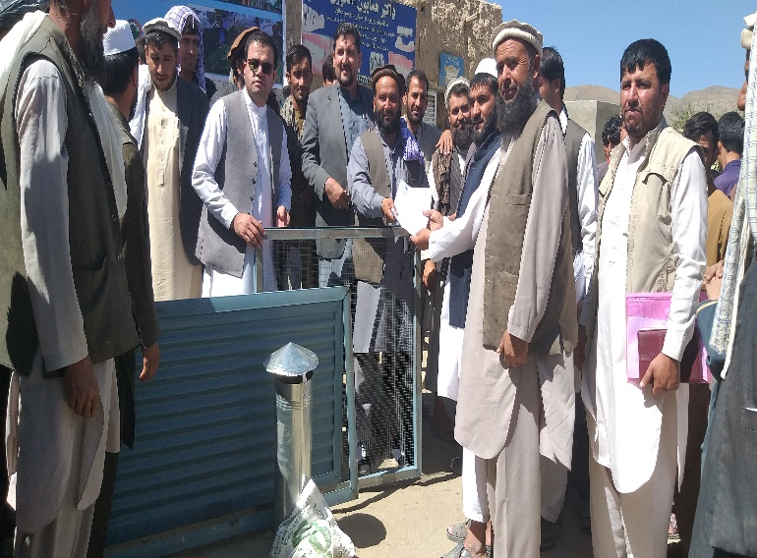
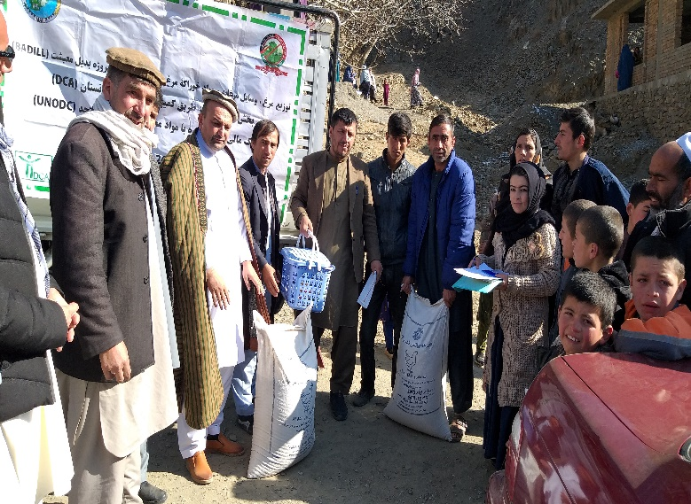
Since the inception of the project, coordination and collaboration have been encouraged among relevant stakeholders and partners in all targeted provinces/districts including provincial and district government authorities, Community Development Councils (CDCs), community elders, line government departments like PAIL, DCN, and DoE. The key staff in each of the aforementioned institutions were informed and consulted for the implementation of major activities, to ensure continued support and active participation of stakeholders in project activities. Several introductory and coordination meetings and joint monitoring missions were conducted and managed in all 6 targeted provinces which resulted in collaborative and informed decisions that ensured the smooth and transparent implementation of the project activities.
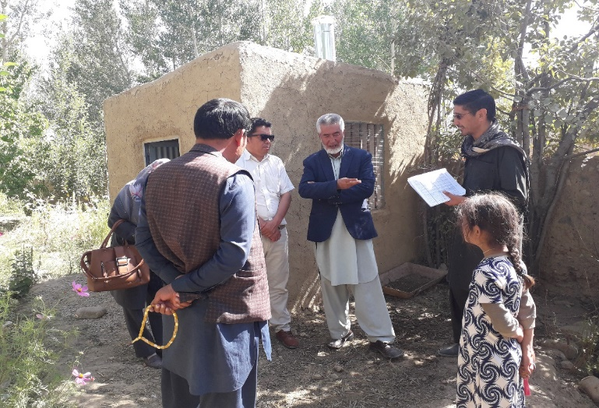
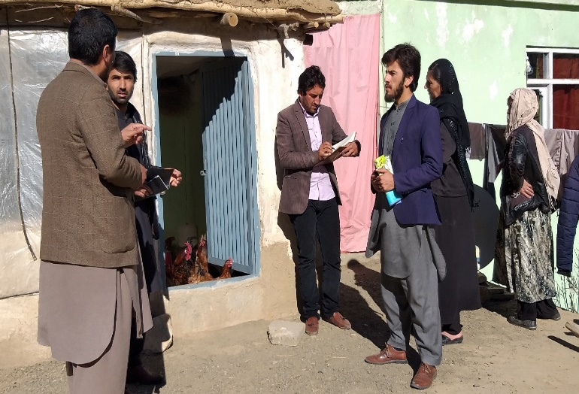

Pictures 1,2,3 & 4: Shows joint monitoring process of provincial and district authorities of government in the project targeted provinces

Project outcomes, outputs, and detailed activities

The overall impact of the project boosted the targeted community’s income generation and better livelihood opportunities through various interventions around livestock and poultry value chains such as:
- Providing quality veterinary and animal husbandry (Animal Health, Feeding, breeding, housing & marketing) services.
- Supporting and establishing backyard poultry farms.
- Increasing awareness and good practices by delivering specific extension training/messages.
- Support and technical assistance in producing quality livestock products.
- Market linkages of the key potential value chains of dairy products and poultry by establishing district-based milk and egg collection centres.
- Introducing new and simple farming technologies that are acceptable and affordable to livestock and poultry owners.
- Breed improvement through Artificial Insemination (AI)

Output 1.1 Improved and strengthened dairy value chain and related livelihoods

The BADILL project dairy component has supported 3,204 female beneficiaries with inputs such as dairy hygiene kits, concentrate feed, molasses/mineral blocks, ventilators, lime, and drinking trough. The training was provided on animal husbandry and dairy processing. Active linking with local VFU’s (Veterinary Field Units) ensures access to quality veterinary services such as curative medicine, vaccination and AI (Artificial Insemination) services. Six established feed banks furthermore ensure the provision of high-quality feed. The cowshed of each beneficiary has been improved. Through demonstrations, beneficiaries learned about the importance of ventilation, access to sunlight, and fixing wall cracks to prevent the prevalence of harmful insects. Since the condition of the cowsheds has improved, beneficiaries have reported significant positive changes in their cow’s health and production status.

Before the project there were poor market linkages and very limited farmers use to sell milk and other dairy products to their neighbours with low and unstable prices. With the BADILL project intervention these households have managed to sell between 90 and 210 litres of surplus milk each month, yielding an average monthly net income in the range of AFN 3,000 to AFN 5,000. In line with the poultry component beneficiaries, these female dairy farmers are now able to contribute to the household income and support their children’s education. The money earned by selling milk can now also be used to accumulate assets and wealth by investing in productive resources such as an additional cow, sheep, goats or poultry.
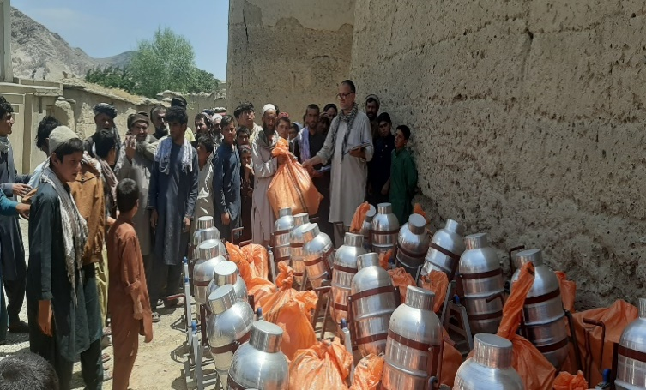
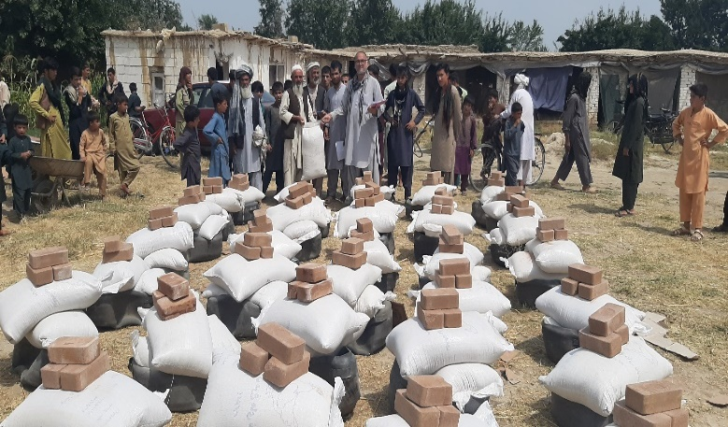
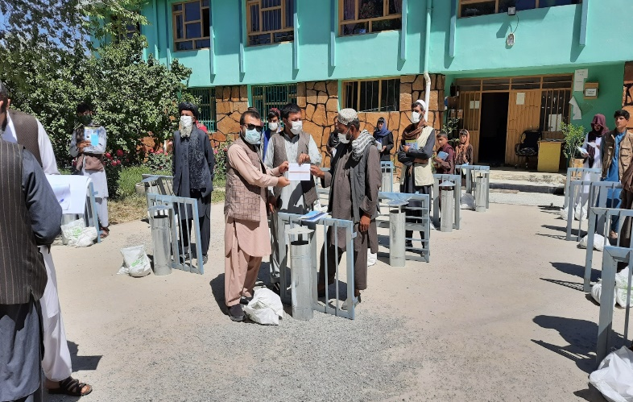
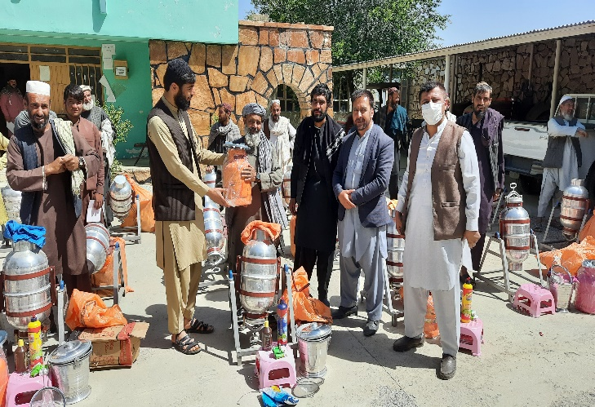
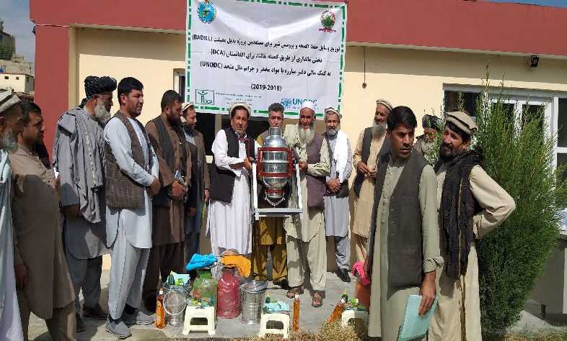
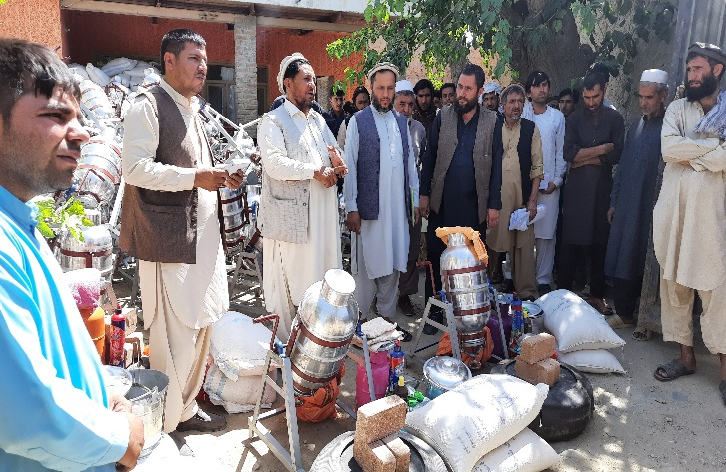
Pictures 5,6,7,8,9 & 10: Showing dairy inputs distribution process in the presence of government authorities in targeted provinces

Establishment of Milk and Egg Collection Centres (MCC/ECC)

BADILL project supports the consolidation of local market opportunities by the establishment of Milk and Egg collection centres. Seventeen districts level local milk and egg collection centres have been established, trained, equipped, and facilitated with a Zarang motorbike for the transportation and collection of milk from the field (Maidan-Wardak (Districts – Maidan-Shar, Behsood 1 and Markaz-e- Behsood), Parwan (Districts - Bagram, Salang and Charikar), Panjshir (Districts – Unaba, Rokh, and Shutol), Bamyan (Districts – Bamyan Center, Yakawlang, Yakawlang 2, Panjab, Shibar, and Saighan )
Kabul (District – Sorobi), Kapisa (District – Tagab) These centres have provided 17 new jobs or additional employment to male entrepreneurs. Each of these centres has the capacity of 500 kg of milk processing per day. On a monthly basis these centres process between 4,000 and 10,000 litres of milk with a monthly net income of AFS 20,000 – 50,000 for the MCC managers. Most of the entrepreneurs selected to operate the milk and egg collection centres already managed a (small) shop. For example, Mr. Abdul Rahman one of the milk and egg collection centres in Panjshir province owned a small food shop where he would sell small quantities of dairy products such as yogurt and qurot. Since the project he has received much larger quantities of milk; 250 — 500 kg milk on a daily basis.
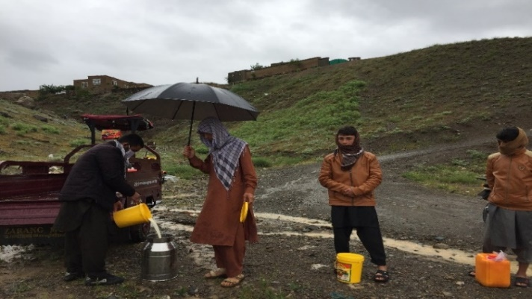
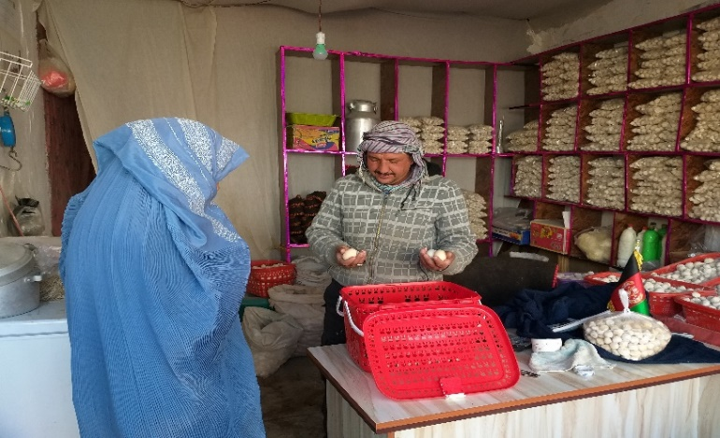
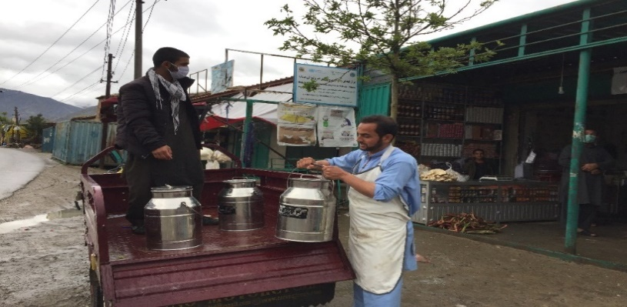
An additional benefit is that this milk is of better quality due to training among the female dairy farmers as well as the ability of the MCCs to test the milk for quality. Consequently, the demand for the dairy products has increased as customer’s value good quality products. The story of Mr. Mujahidin from Parwan is similar, he owned a small food shop and has now expanded his dairy product section and is receiving between 250-400 kg on average on a daily basis. The milk collection centres yielded a monthly income in the range of AFN 20,000-50,000.
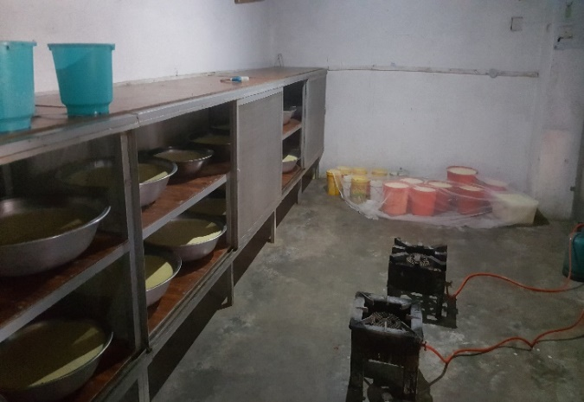

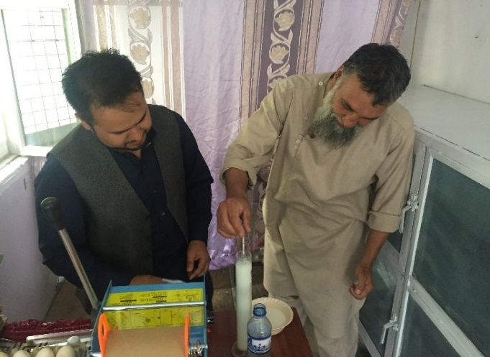
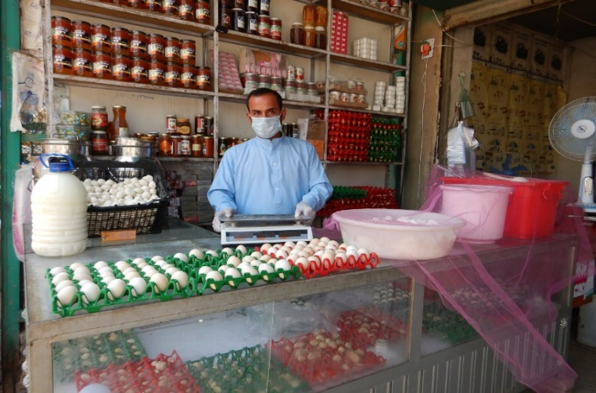

Pictures 11, 12, 13, 14, 15 & 16: Shows milk collection centers activities in targeted provinces

Antimicrobial Resistance (AMR) and residues

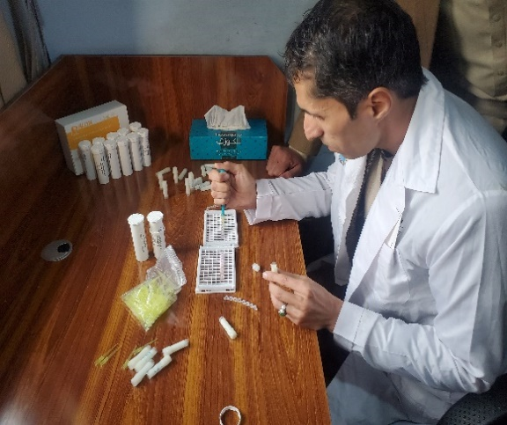
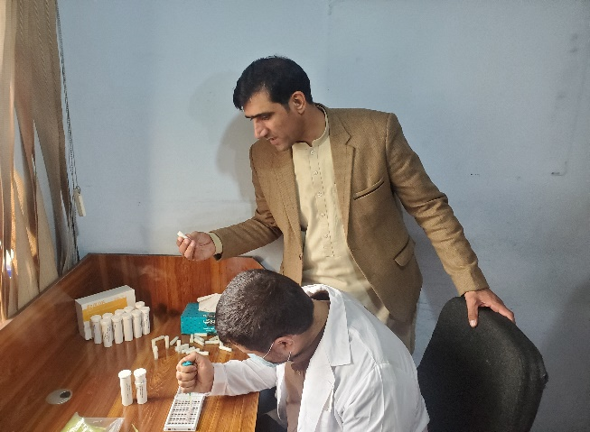
The misuse of and uncontrolled antimicrobial medicine use in animals can have harmful effects on consumer’s health, especially when the withdrawal period is not observed by producers. The presence of antibiotic residues can lead to microbial resistance and public health concern. To understand the current situation in terms of antimicrobial residues in raw milk, experimentally and randomly 170 milk samples were collected from Parwan, Panjshir and Wardak provinces. The rapid enzyme-linked receptor-binding assay test was carried out and the obtained result showed the presence of antibiotics (Tetracyclines and Penicillin) residues in milk, with 16 positive samples (9%). The results indicate that the farmers do not always respect the time between the administration of antibiotics and milk collection, therefore, there should be a monitoring system in place to bring awareness to the livestock farmers/producers and retailers regarding the health hazardous and effects of antimicrobial drug residues and continuous supervision is needed on the use of these drugs to ensure a safe supply of animal based food of good quality, and also the milk containing antibiotic residues should be declared unfit for human consumption.
Pictures 16 & 17: Shows the process of examining milk samples for the detection of antibiotic residues

Livestock extension and outreach through FBVWs

Extension, outreach, and training are an integral part of the DCA/BADILL project interventions which make the farmers aware of low-cost/no-cost farm technologies, best practices in animal health and husbandry. All 5,000 targeted beneficiaries have been organized into 384 farmer extension/producer groups (FEGs) (247 dairy extension groups, 130 poultry producer groups, and 7 kitchen gardening groups). The extension program varies from advice to individual farmers to regular meetings of farmer extension/producer groups. The complementary approach of input provision, service delivery, and extension has led to the successful implementation of the BADILL project. The extension services promote the linkages between farmers and local service providers which have increased demand for their services. As 90% of the BADILL project beneficiaries are women, the women-to-women extension has been used as a successful approach. Therefore, DCA under the BADILL project trained, equipped, and have supported 38 Female Basic Veterinary Workers (FBVWs) to provide basic animal health services and spread extension messages on relevant livestock topics, one health issues involving human/animal and zoonotic disease including the COVID19 outbreak. Involvement of women in project activities enhances their self-confidence and social status. It also increases women’s contribution to the family’s income. Fortunately, recently communities have been sensitized to the importance role of women in contributing to household income and community economic development. Therefore, FBVWs are an indispensable and important component in the empowerment of women in the targeted provinces.
Communities have been trained in One Health issues covering human/animal and zoonotic diseases, including COVID-19. With the outbreak of COVID-19 in Afghanistan, the VFUs, female BVWs and project staff received ToT training in order to conduct awareness campaigns among the project communities. Luckily, during the lockdown period, the BADILL project was allowed by the Government line ministries to operate and continue work with the communities with due consideration given to safety measures for the protection of both the project staff and beneficiaries.
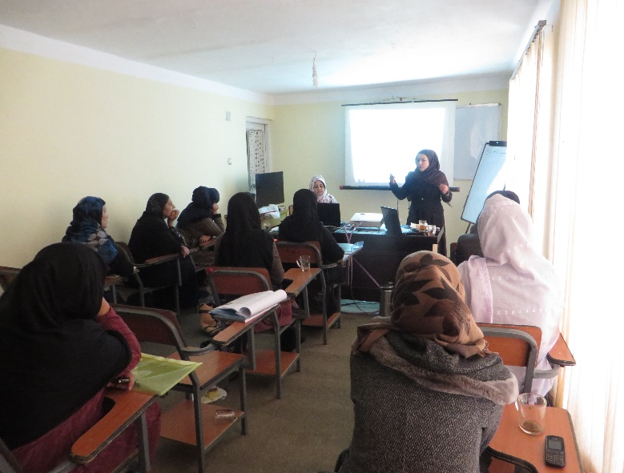
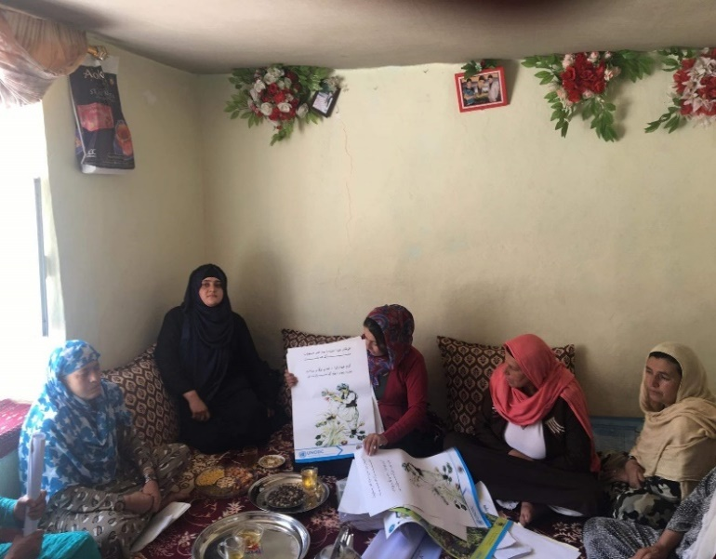
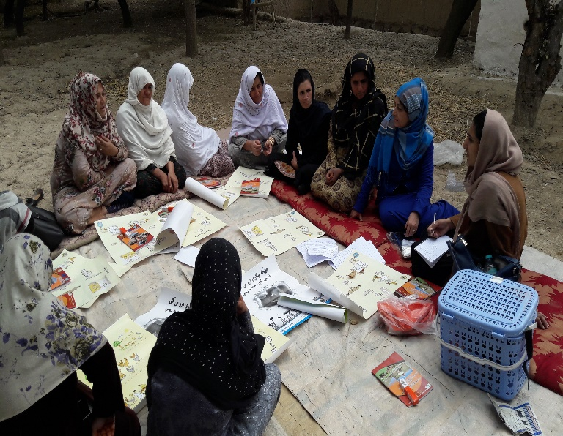
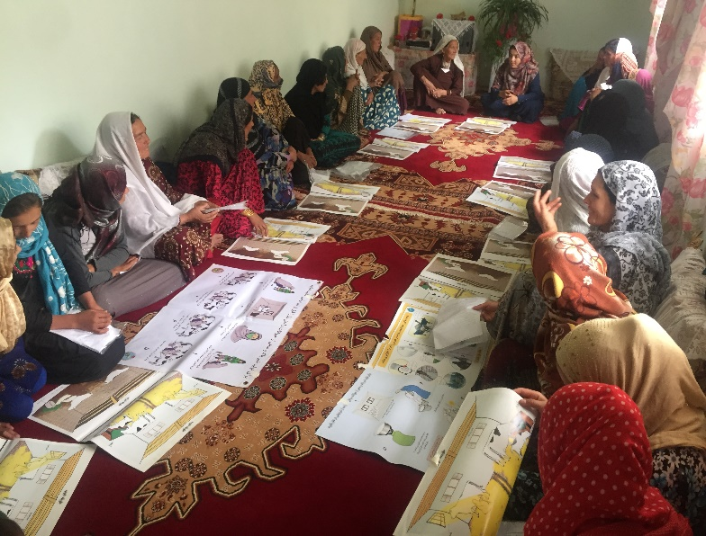
Pictures 18, 19, 20 & 21: Shows female farmer extension group sessions led by FBVWs

Raising community awareness on COVID-19:

The activity for the response to the COVID-19 emergency has planned for the general awareness of people, particularly the BADILL project beneficiaries about COVID-19 that is currently threatening the world, DCA through the BADILL project has always been doing its best possible endeavours to increase/inform the targeted communities about the hazards of the virus. Therefore, considering the outbreak of COVID-19 and the report of confirmed cases from almost all provinces of Afghanistan DCA in consultation and coordination with UNODC/donor on May 1st, 2020 commenced the public awareness campaign through 17 VFVs and 38 FBVWs within the BADILL project targeted provinces including Kabul, Kapisa, Parwan, Panjshir, Wardak and Bamyan. Items including 18,000 bars of soap and 18,000 face masks were distributed to 9,000 farming households in the above-mentioned provinces. Furthermore, each household has been informed about the preventive and hygienic measures to take, e.g., proper handwashing and social distancing that they could use to help protect themselves and their families.
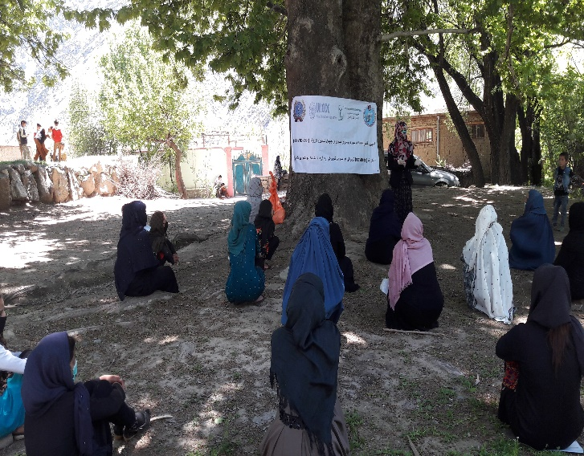
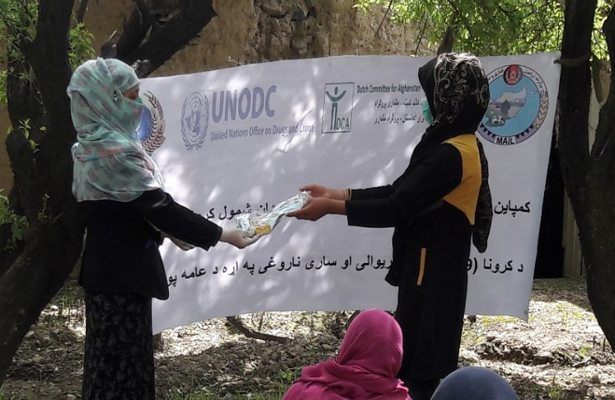
Pictures 22 & 23: Shows awareness session and distribution of COVID19 preventive kits

Access to quality veterinary services:

Lack of animal health services and the prevalence of animal diseases with high morbidity and mortality have resulted in an afghan livestock sector with very low productivity. The network of 17 VFUs and 38 trained female BVWs in 6 targeted provinces (Parwan, Panjshir, Bamyan, Wardak, Kabul, and Kapisa) supported under the BADILL project enhances the accessibility of farmers to veterinary services. During the project implementation period in the mentioned provinces, 719,354 animals were treated and vaccinated. The provision of VFU services includes vaccination, treatment, health care, small surgery, breed improvement, advice on better animal welfare, feeding, housing, and disease control. VFU staff, particularly during the emergency of COVID-19, regularly visit and provide relevant services to villages in their communities. Enhanced access to livestock services resulted in a positive impact on the economical position of livestock owners, particularly farmers living in remote villages of the targeted provinces. This has improved access to quality veterinary services through a comprehensive community-based approach which has improved the health and productivity of livestock. This is reflected by the decrease in infectious disease prevalence as reported by the VFUs. As a result of improvement in animal welfare and with knowledge and skills in communities, an increasing number of households invest in dairy animals and backyard poultry farms.
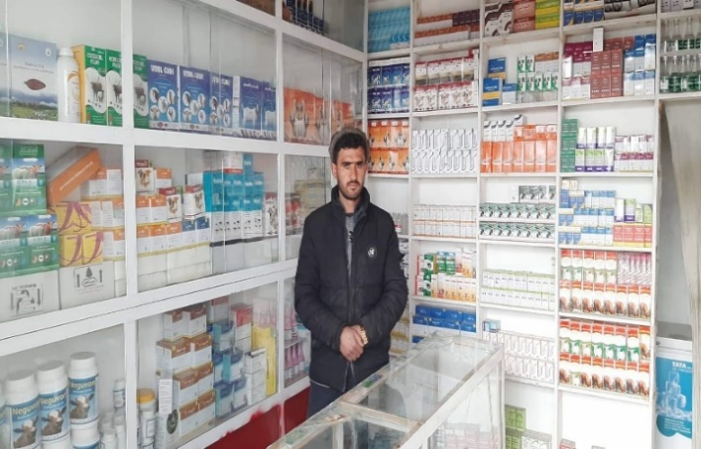
In addition to the male operated VFUs, 38 female basic veterinary workers were selected and trained to provide basic animal health information and veterinary services to women. Provision of animal healthcare services by women has enabled direct service provision to livestock in the care of women where before these services had to be negotiated via male family members.
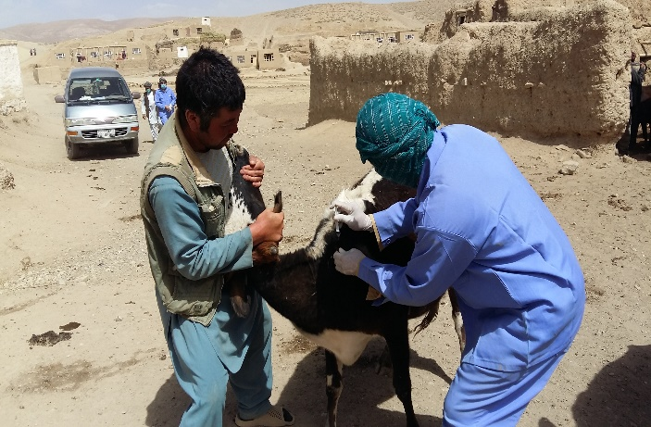
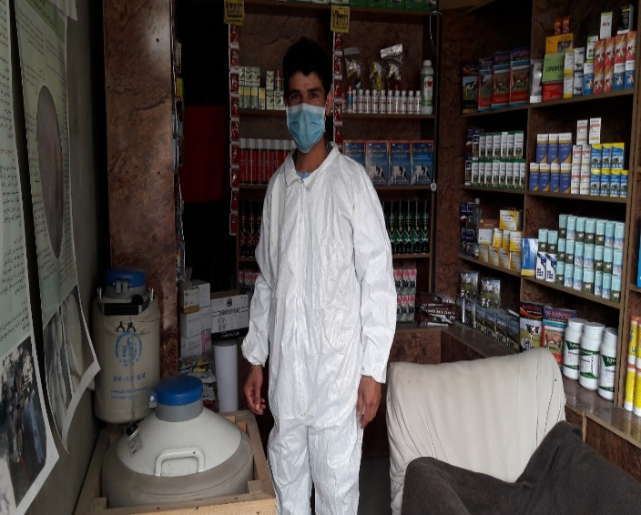
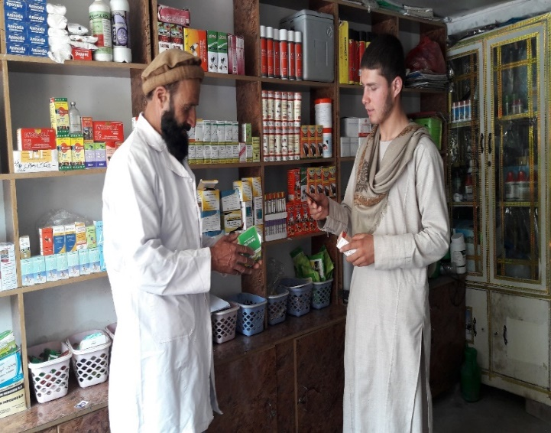
Pictures 24, 25,26 & 27: Shows supported VFUs by UNODC-BADIL project providing services to farmers

Table 1: Shows the number of treated animals in targeted provinces

SN | Province | Number of treatments in 2019 | Number of treatments in 2020 | Total # of treatments
1 | Kabul | 15,235 | 60,481 | 75,716
2 | Parwan | 12,291 | 36,623 | 48,914
3 | Panjshir | 13,244 | 20,343 | 33,587
4 | Bamyan | 18,793 | 77,796 | 96,589
5 | Maidan Wardak | 6,593 | 8,350 | 14,943
6 | Kapisa | 4,154 | 4,749 | 8,903
Total |  | 70310 | 208,342 | 278,652

Table 2: Shows the number of vaccinated animals in targeted provinces

Sn | Province | Number of vaccination in 2019 | Number of vaccination in 2020 | Total # of vaccination
1 | Kabul | 9,270 | 82,960 | 92,230
2 | Parwan | 48,005 | 78,732 | 126,737
3 | Panjshir | 14,360 | 17,626 | 31,986
4 | Bamyan | 32,085 | 115,959 | 148,044
5 | Maidan Wardak | 11,965 | 26,101 | 38,066
6 | Kapisa | 1,452 | 2,187 | 3,639
Total |  | 117,137 | 323,565 | 440,702

Breed improvement through Artificial Insemination in dairy cattle
Crossbreeding is recognized as the fastest option for breed improvement and genetic make-up of the local breed cows. It is a viable technology applied in improving and/or increasing milk production and productivity of dairy cows. Keeping a large number of low-productive cattle contributes to feed shortage, land degradation, and environmental pollution. Productivity can be increased by modifying the genetic make-up of cattle and their production while safeguarding the environment. Therefore, DCA under the BADILL project trained, equipped, and have been supported 6 VFUs on artificial insemination activities in Kabul, Parwan, Panjshir and Wardak provinces to provide breed improvement services through Artificial Insemination (AI) in project targeted areas. During project implementation through 6 established AI centres, 2,170 dairy cows were artificially inseminated, and 475 exotic breed calves were born as a result of AI. The AI program aims to increase milk production and the market value for both the artificially inseminated cows, and resulting calves appear to be higher than that of the naturally inseminated dairy cows and the local breed calves. For this additional value, the number of cows in heat brought by the farmers to the AI stations is increasing. For the future follow-up, a standard record system was introduced and used to record inseminated cows, and the AI resulted calves. For easier recognition, all the AI resulted calves were identified by ear tags, provision of calf cards, and registration.
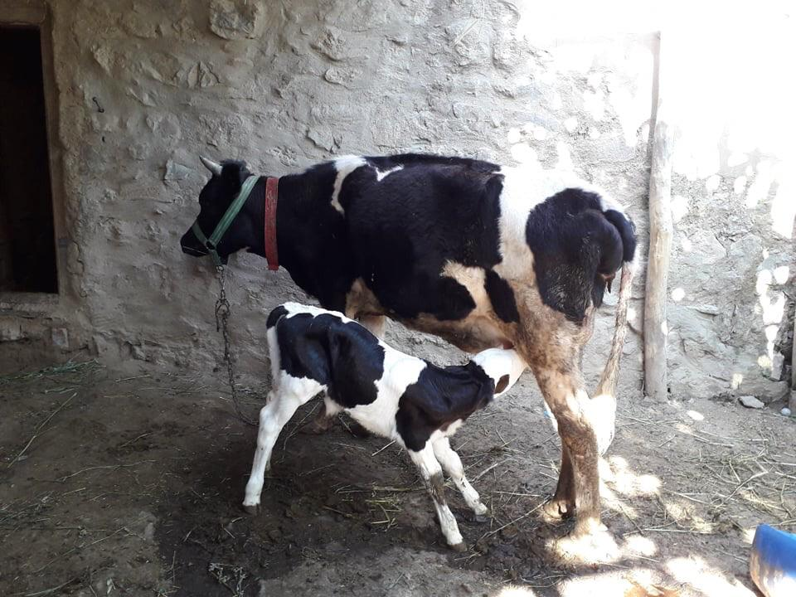
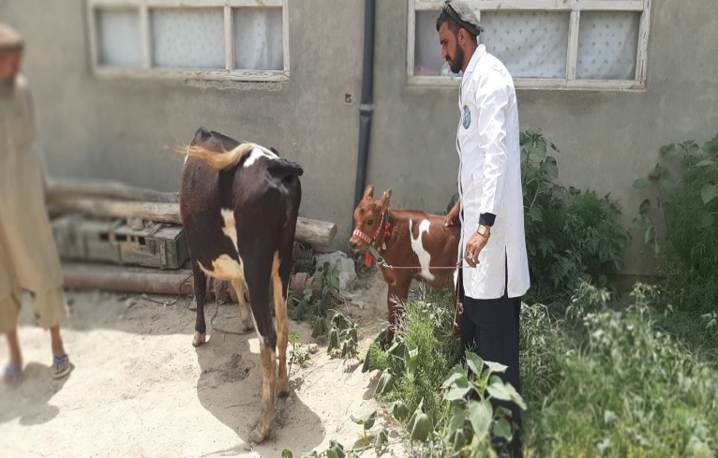
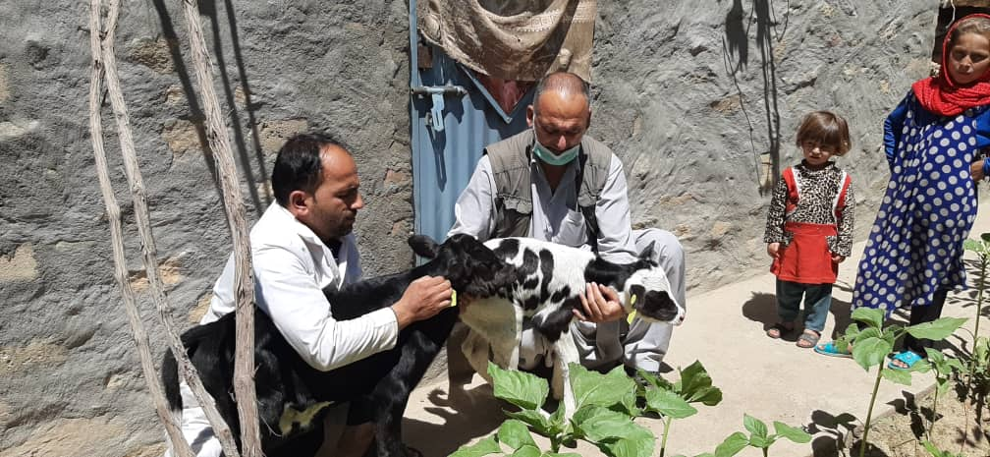
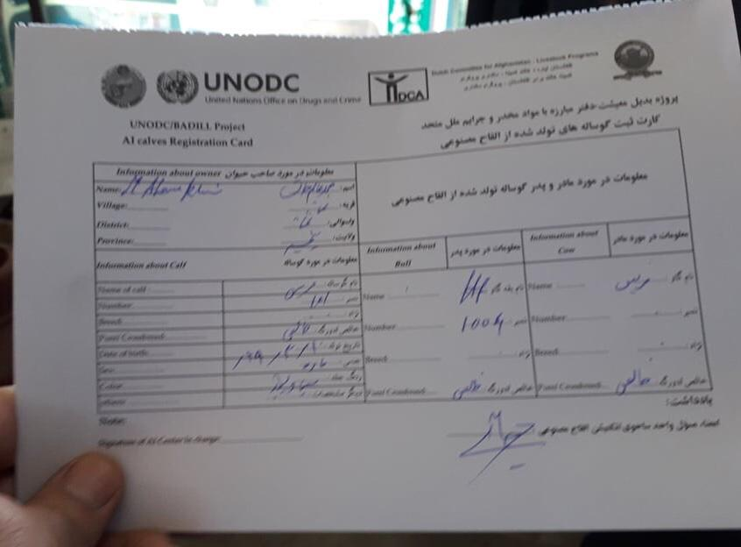

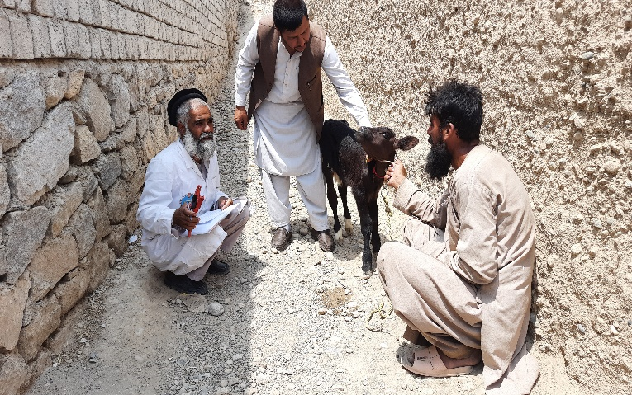
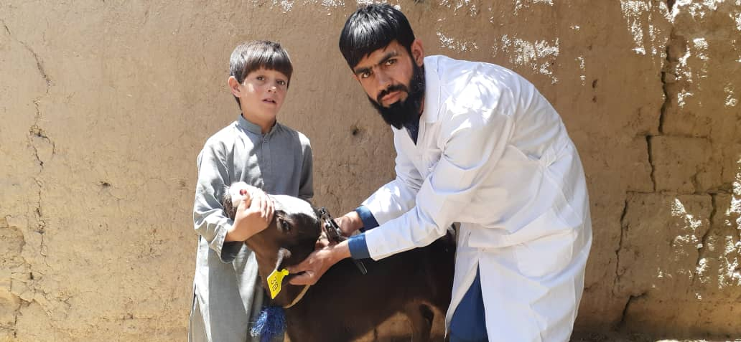
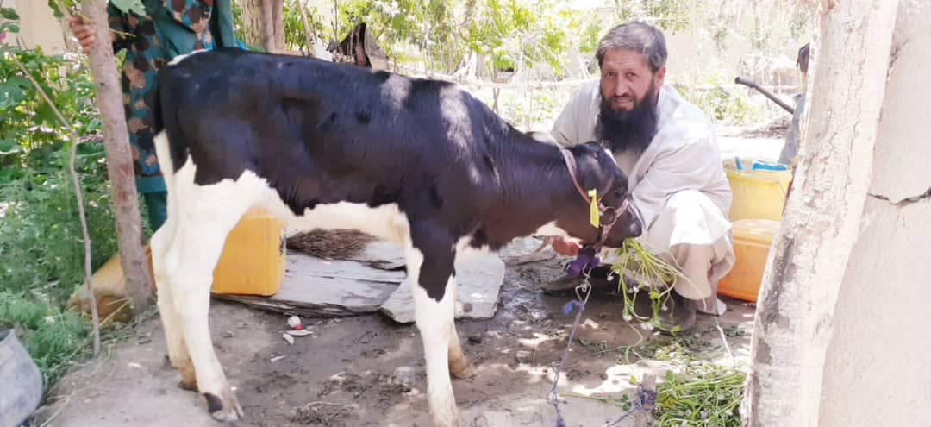
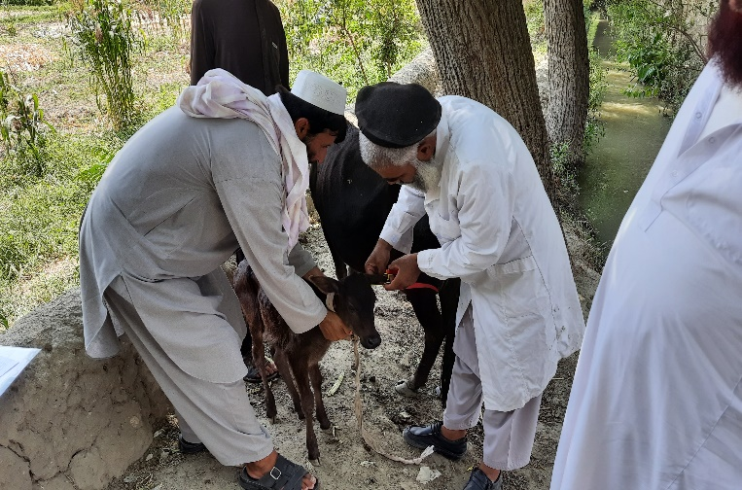

Pictures 28, 29, 30, 31, 32, 33, 34 & 35: Shows calves born as a result of artificial insemination and the calf registration card

Table 3: Shows the number of cows artificially inseminated and calves born in 4 targeted provinces
SN | Province | District | # of cows artificially inseminated | # of calves born in 2020
1 | Maidan Wardak | Maidan Shahr | 195 | 44
2 | Kabul | Surobi | 829 | 201
3 | Parwan | Bagram and Charikar | 609 | 76
4 | Panjshir | Unaba and Rukha | 537 | 154
Total |  |  | 2,170 | 475

Community-based livestock Feed banks:

Six community-based feed banks have been established at strategic locations (Parwan/ Charikar and Sayad, Wardak/Madidan Shahr, Panjshir/Unaba, Kabul/Sorubi and Bamyan/Bamyan center where the need for animal feed is the highest and most difficult to access for local communities. These feed banks provided employment to male members of the community who have been trained and equipped. They are established under a committee, of which one person takes the daily management and receives a percentage of the turn-over. The initial support through the project for each feed bank included the supply of 16 metric ton of different kinds of balanced feed raw materials, vitamins+ minerals, 1 feed mill with a machine, labelled bags, bag sewing machine, 1KW generator, 1 scale, registers for proper recording system, and feed formula to be used by the feed bank manager for the production of standard and balanced feed. The CDC/farmers with the feed bank managers established a revolving fund so that farmers were charged for the feed they withdrew, and then this would be used for restocking purposes, maintain the bank's function, and ensure the sustainability of the banks. The managers also received training in business skills.
Each feed bank covers 3-4 larger project's targeted communities. These feed banks provide the dairy and poultry beneficiaries with the opportunity of access to year-round quality balanced poultry and livestock feed. The feed banks implemented by the project help in stabilizing these prices. Quality feeding is among the most important factors for improving animal health and increasing livestock productivity.
The access to feed banks has improved for all provinces. One feed bank provides concentrate feed for 3-4 villages where up to 200-300 farmers’ households are living. These feed banks addressed the main challenge faced by the farmers which was the lack of balanced feed, particularly during the winter period or drought. Beneficiaries have reported a clear improvement in the health of their animals and an increase in productivity due to the year-round availability of quality feed at a reasonable price.
Previously dairy and backyard poultry farmers suffered from the lack of quality feed availability in local markets and needed to be supplied with low-quality feed from outside the provinces with a higher transportation cost.
The establishment of feed banks provided sustainable feed supply sources for marginalized farmers and villagers and encourage the entrepreneurs and farmers to invest in their livestock/livestock products and the poultry sector.
All feed bank managers were provided with the training for producing formalized and quality concentrate feed. They were trained also to consider seasonality as well as the proper selection of quality raw ingredients. Therefore, a standard formula for both the poultry and dairy animal feed was applied to produce a balanced feed, and fulfil the requirement of the animals.
Since mid-2019 to 2020, 95,000kg of dairy and poultry balanced quality concentrate feed has been produced and sold by the established feed banks. Generated income from each Kg of sold concentrate feed for the bank managers was calculated at AFS 5; therefore, the average income for each feed bank is AFS 10,000/month.

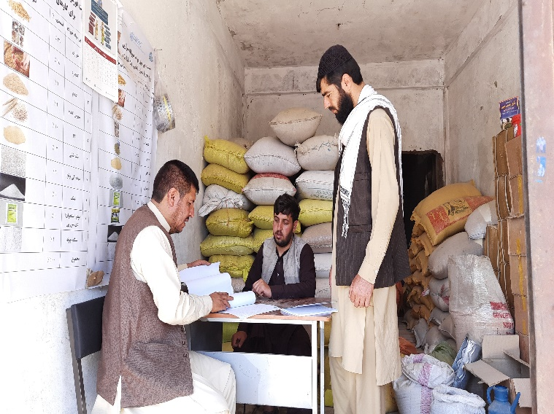
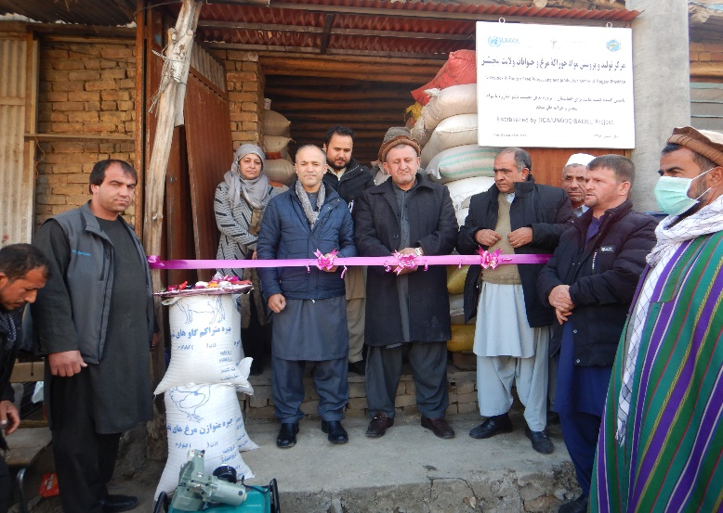
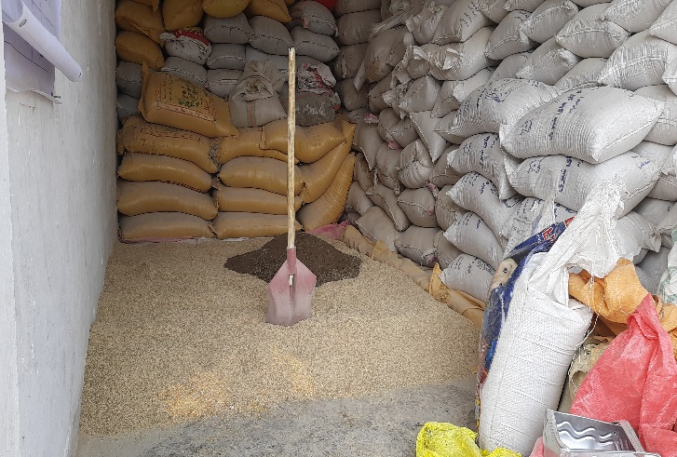
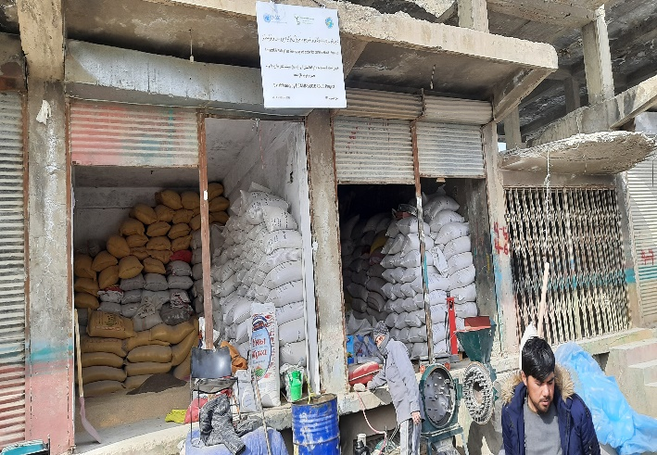
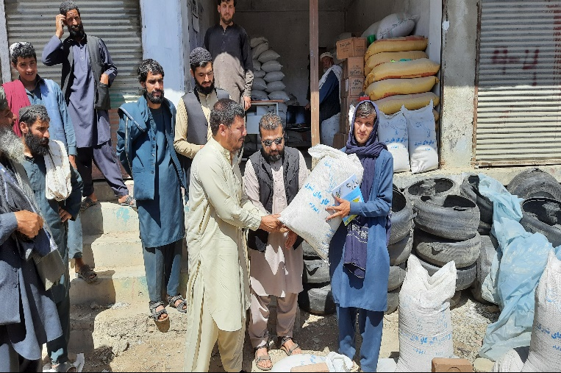
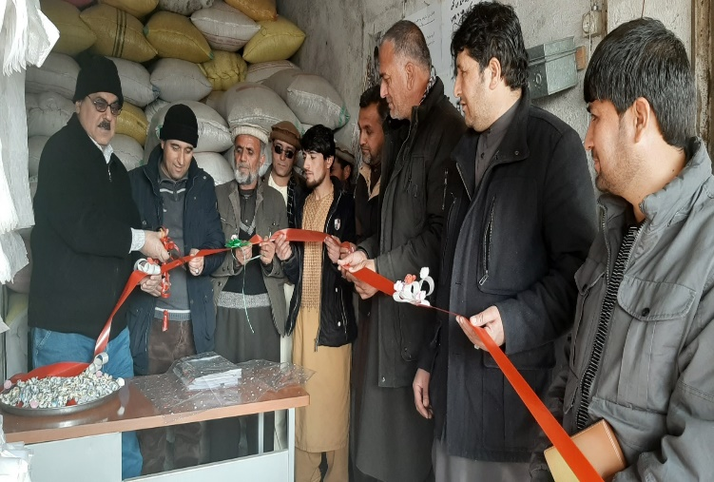

Pictures 36, 37, 38, 39, 40 & 41: Shows community-based feedbacks in project targeted provinces

Cowshed improvement

The poor condition of cowsheds in targeted provinces is usually not well-known by livestock owners. Through demonstrations, farmers learned about the importance of ventilation, access to sunlight, and fixing wall cracks to prevent the attack of harmful insects. Since farmers learned the importance of improved cowsheds and improving the condition of their cowsheds, they have revealed a significant change in the health and production status of their animals. The intervention encouraged other villagers who are not direct project beneficiaries to copy and replicate cowsheds improvement with consulting with benefited farmers in their farms for better results and enhancement of animal health and welfare.

During the reporting period, 3,024 beneficiaries have been supported with inputs such as windows, ventilator, and lime to improve their livestock cowsheds. As a result, 3,204 cowsheds have been improved in Bamyan, Parwan, Panjshir, Wardak and Kabul provinces.

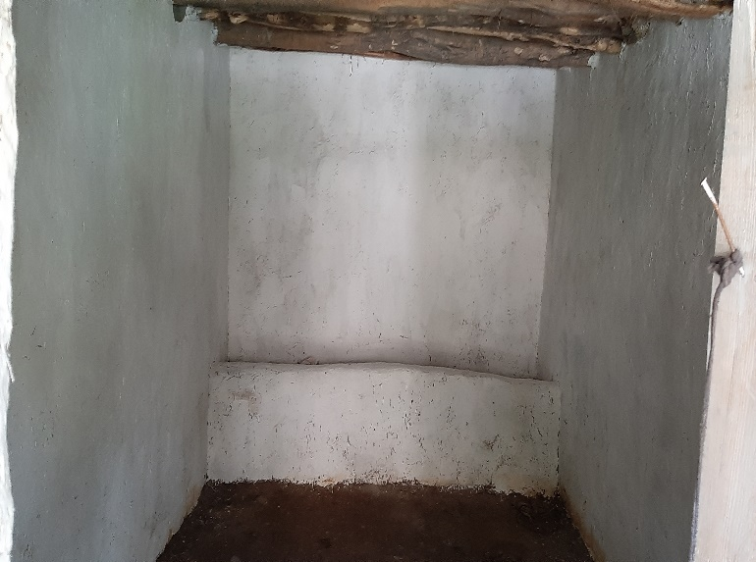
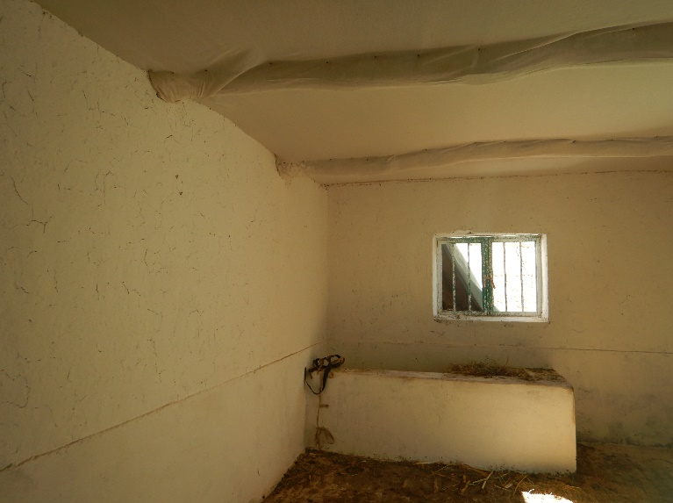
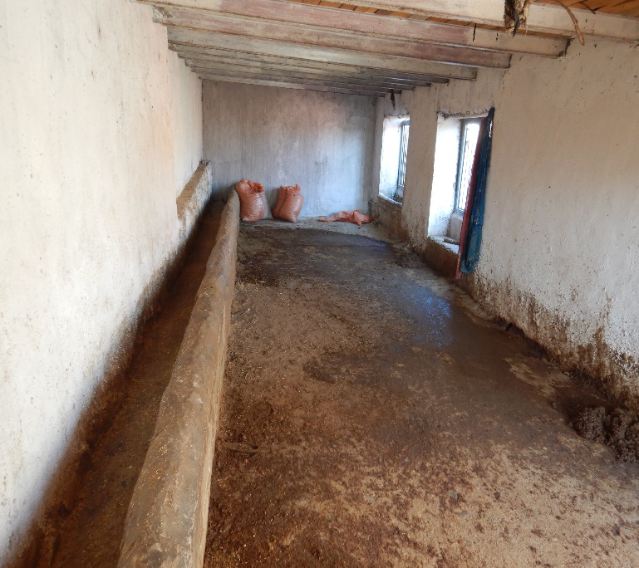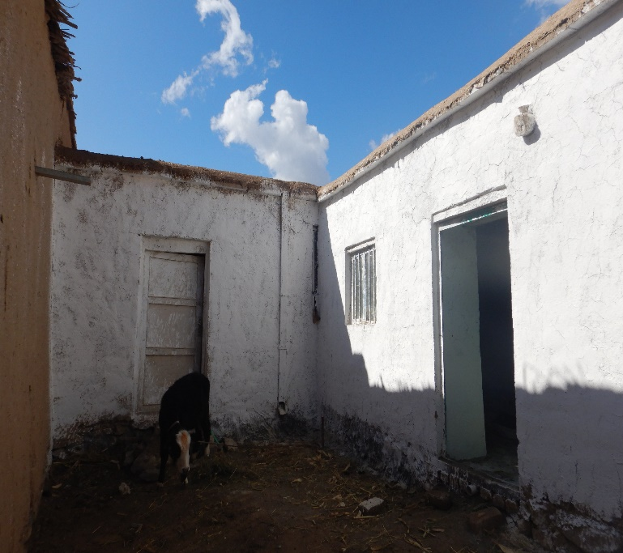

Pictures 42, 43, 44 & 45: Shows cowshed improvement

Fodder production

During the project implementation period, improved fodder seeds were introduced and distributed to more than 1,500 dairy beneficiaries. In addition, 245 farmers’ extension groups (FEGs) in the targeted provinces practiced and learned about local fodder storage systems for the winter, and animal feed processing such as silage making and urea treatment.
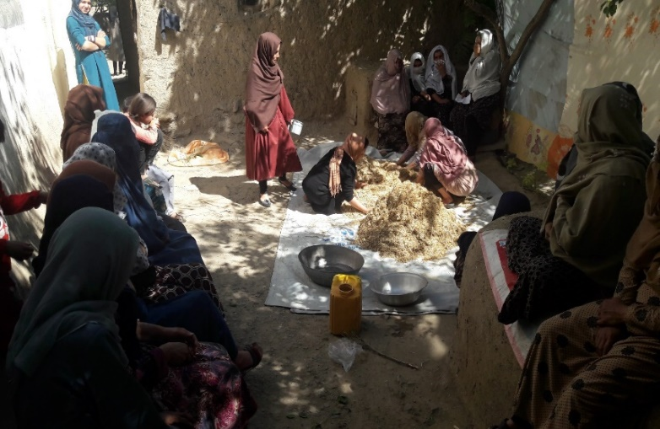
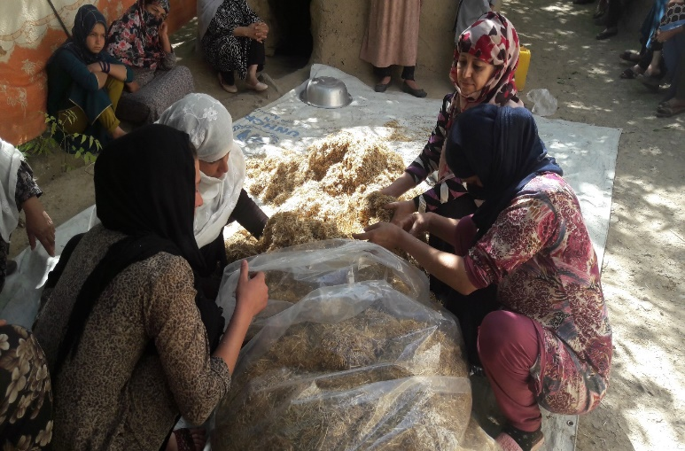
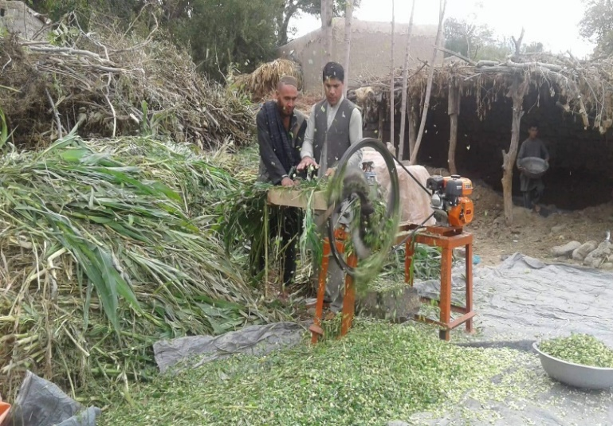
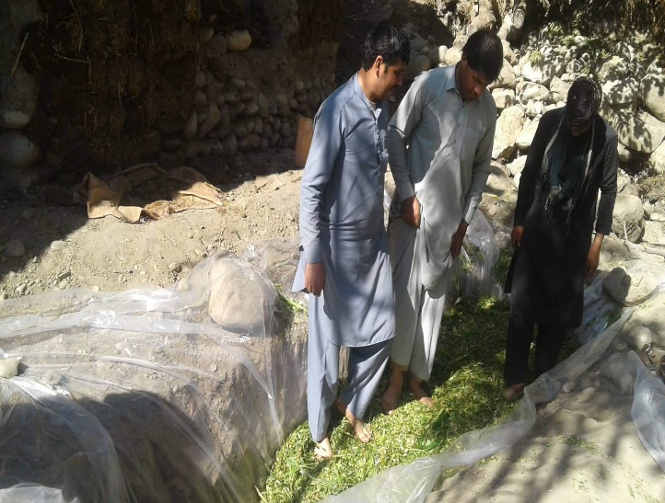
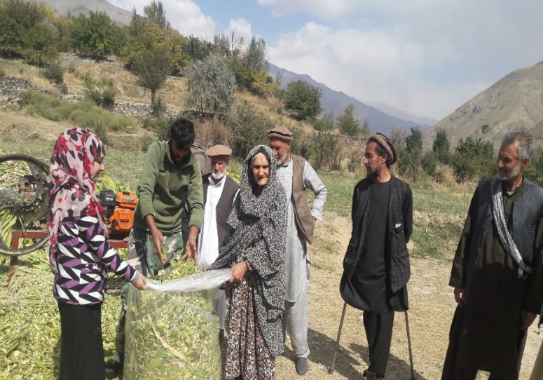
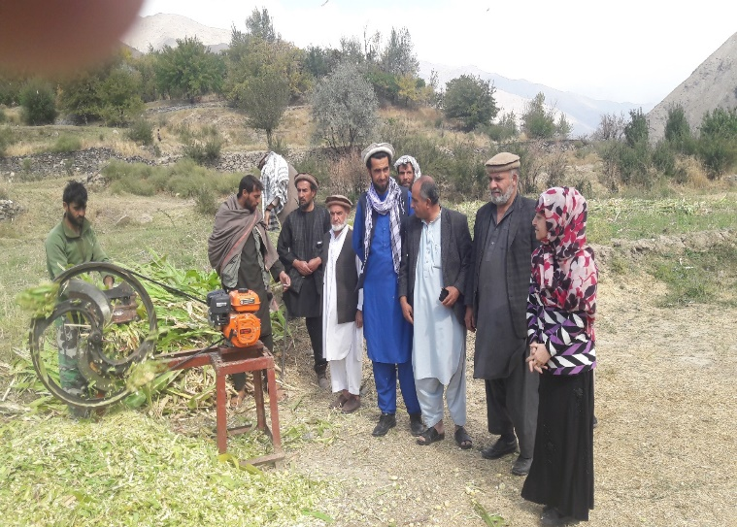
Pictures 46, 47, 48, 49, 50 & 51: Shows the silage and urea treatment making process

Output 2 Backyard poultry farming improved and strengthened among the target beneficiaries:

In order to ensure the sustainability and effectiveness of this particular activity, a lot of attention has been paid to the selection criteria of the poultry component beneficiaries. Criteria have been developed including approval and support from husbands and/or family members and local leaders. Another criterion includes the genuine interest of the beneficiary in poultry keeping, and the willingness to attend training and to contribute more than 50% of the costs for coop construction in cash or in-kind. Besides the priority is given to those who are poor, widowed, and disabled or have recently returned to their villages. Preference is also given to those households/members who are under treatment for drug abuse, and are not using drugs anymore.
DCA under the poultry component of the BADILL project supported 1,700 beneficiaries each with inputs such as windows, ventilators, lime, plastic, feeders, and drinkers. As a result, 1,700 chicken coops were constructed, and these will remain as an asset for proper backyard poultry rearing in the long term. Beneficiaries received training on poultry management, health, and feeding. They were linked with the Veterinary Field Units (VFUs), and female basic veterinary workers (FBVW) to ensure access to basic veterinary services, and timely application of vaccinations (in particular vaccination against Newcastle and Infectious Bronchitis which usually cause high mortality rates among poultry).

To date, 1,700 (600 with 30-layer chickens and 1100 with 20-layer pullets) backyard poultry farms have been established, these are managed by women and due to the application of good managerial practices, only a limited number of mortalities among these birds have been reported.
All poultry beneficiaries through the farmer extension/producer groups (FEGs) have been linked to a district local milk and egg collection centre. Each of these milk and egg collection centres receives on average 300-450 eggs per household/month. For marketing purposes, DCA introduced an efficient method of egg packaging, which reduced breakages. At these centres, surplus eggs are sold, which results in a monthly net profit in the range of AFN 2460 to 4125.

Moreover, the project has resulted in improvements in household diets by increasing the number of eggs for home consumption. Eggs are a source of high-quality protein and provide essential micro-nutrients such as vitamin B12, phosphorus and riboflavin.

In addition to the tangible benefits of increased household income and improved diets, this component also contributed to the empowerment and well-being of the female beneficiaries. Among the majority of target households within the BADILL provinces, women are limited in their mobility due to social-cultural restrictions. They are largely confined to their compounds where their primary responsibility is taking care of their children in addition to animal husbandry activities that take place within the family compound. However, these activities are largely unpaid and unrecognized. Poultry keeping is one of a few incomes generating opportunities that are easily accepted among male members of the household and the community in general as the majority of activities take place within their compounds. Many women were not earning any (significant) income before the BADILL project but are now able to support their families and pay for their children’s education. Some have started breeding pullets to give away to other female family members and are encouraging other women in their communities to also start poultry keeping.

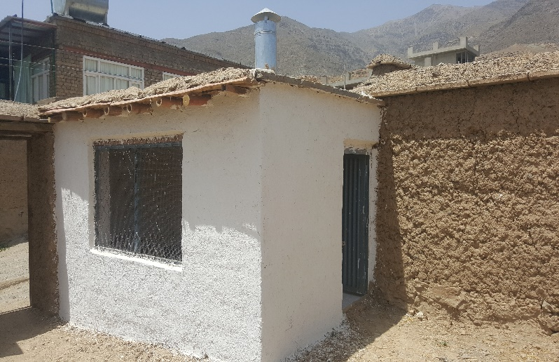
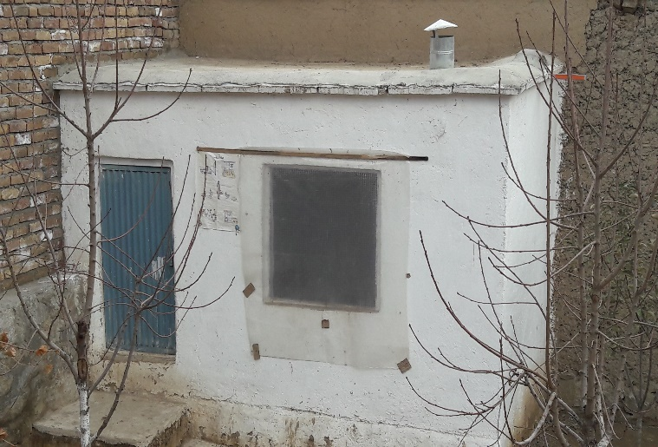
Pictures, 52 & 53: Shows improved chicken coops
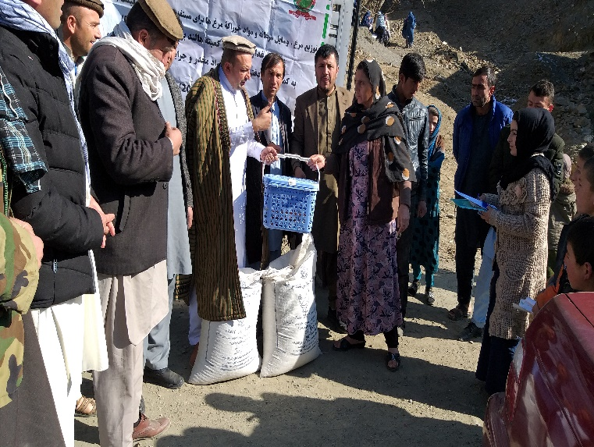
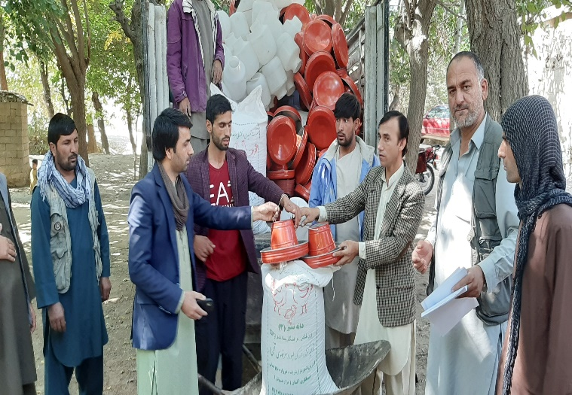
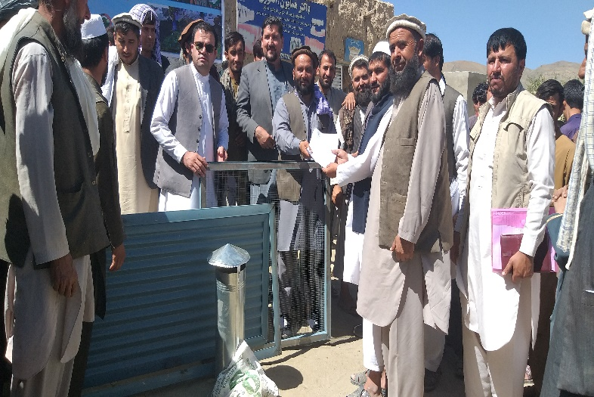
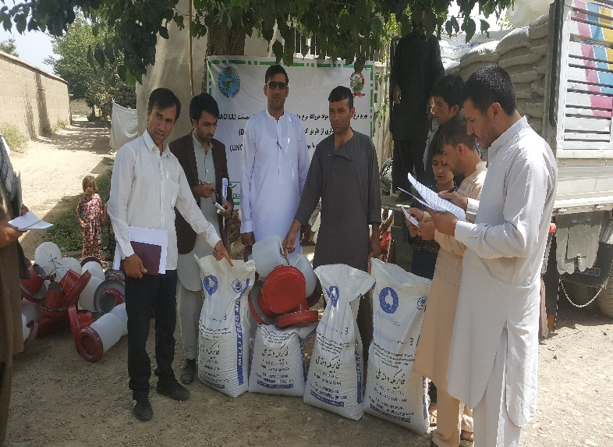

Pictures 54, 55, 56 & 57: Shows chicken coop equipment and feed distribution process

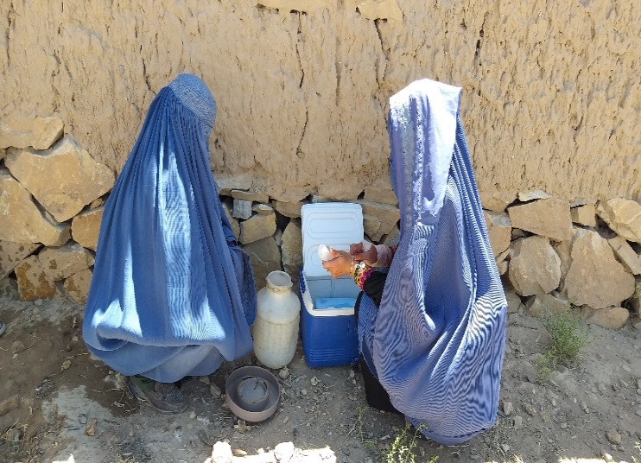
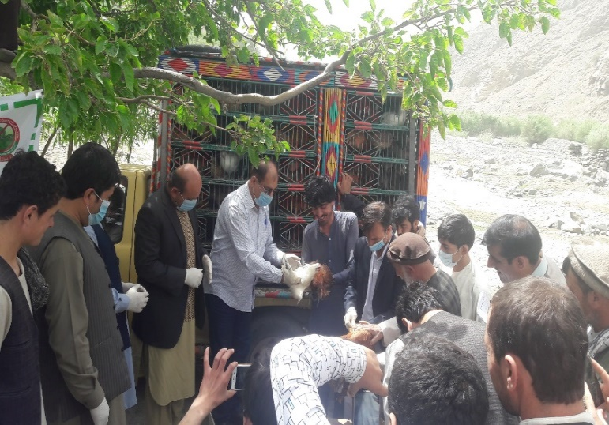
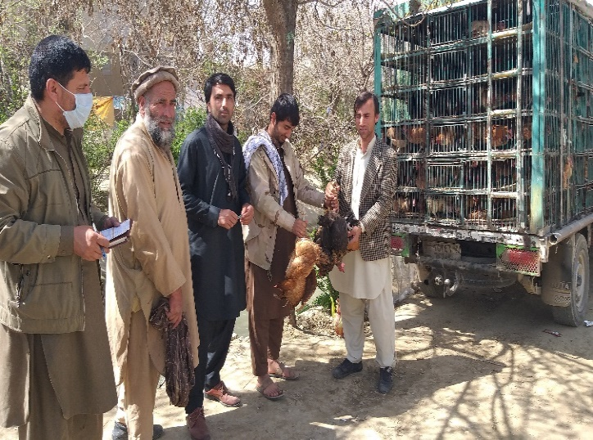
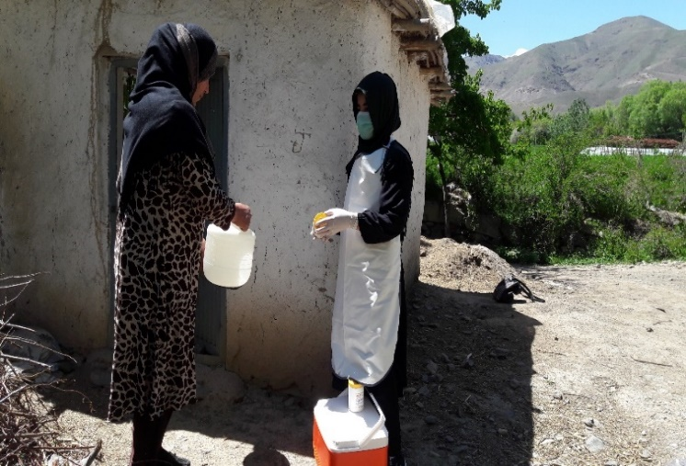
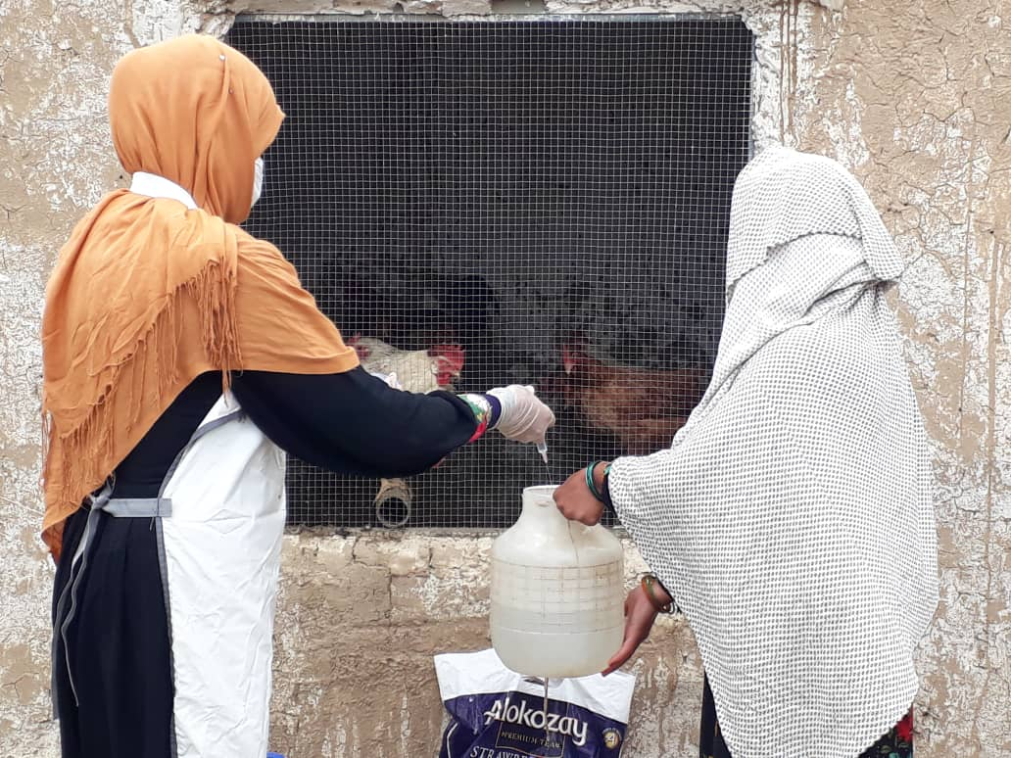
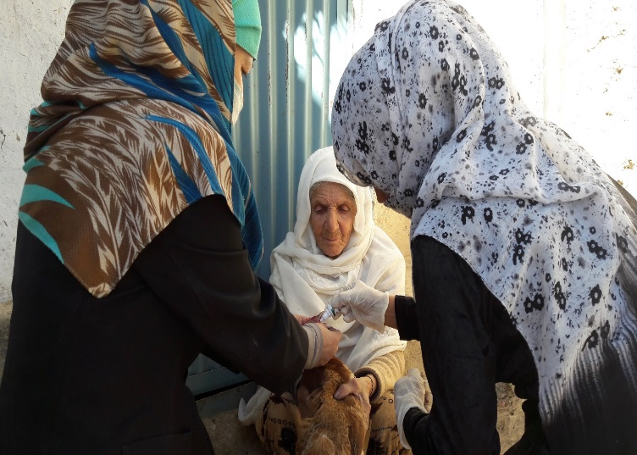
Pictures 58 & 59: Shows pullets distribution process in targeted provinces
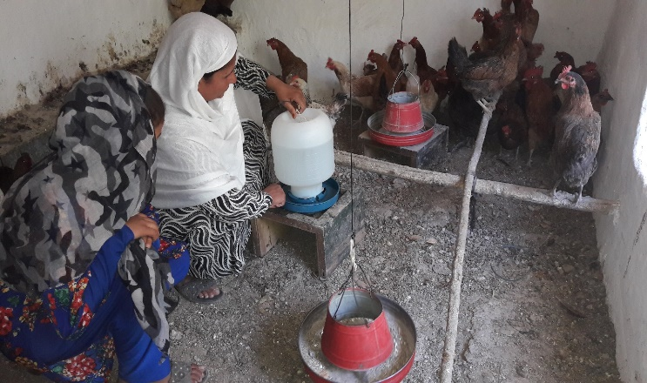
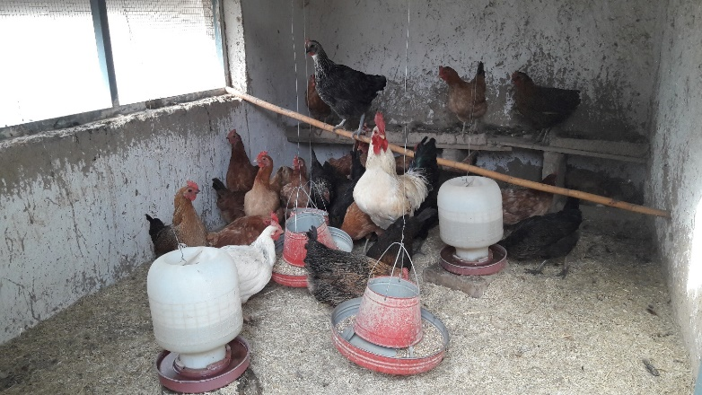
Pictures 60, 61, 62, 63, 64 & 65: Shows vaccination campaign against Newcastle disease through FBVWs

Project evaluation and outcome:

For the better recording of the produced eggs by the backyard poultry farms, the data collected from beneficiaries was regularly collected on a weekly basis. Studies, records, and reports by the project team. the data indicated that the distributed 40,000 pullets to 1,700 farmers produced 7,113,856 eggs during the production season (1,330,612 eggs consumed at home and 5,783,244 eggs sold). Deducting the total expenses from the total selling price shows AFS 48,466,500 as the net benefit. The price of eggs increased because of the border closure, and this has helped the livelihood of the project beneficiaries, especially during the lock-down period due to COVID-19 as they had access to protein, and there was a good market for their produce.
The collected data showed that besides eggs consumed by producer households, on a monthly basis they earn around 2,460 to 4,125 Afghani net income from selling fresh eggs in the local markets. Therefore, poultry farming significantly contributes to farmer livelihoods in terms of food and cash. The income generated allows households to purchase other necessary items such as tea, sugar, clothes, fuel and other needed items. Farmers encouraged to expand and invest in poultry farming as an evidence 4 broiler poultry farms established in Parwan province, where they have provided with the training and direct technical support of the project. Below is the Ms. Nargess story as an example.

The story of Ms. Nargess:
One of the beneficiaries of this project is Ms. Nargess, a mother of 6 children. She lives in Deh Mullah Village-Bagram District of Parwan province. She has been introduced to DCA through local council and after completion of the assessment done by the project team she became a beneficiary of the BADILL project. Through this project she has received packages including 30 pullets, 200 Kg improved poultry feed, feeders, drinkers and other necessary coop equipment such as a poultry hygiene kit, door, window, and ventilator.
She was trained by experienced project master trainers in poultry basic management and linked with the nearby market/Milk and Egg collection center. These have been facilitated and established under the BADILL project of UNODC.
She quotes “In the past, I had no specific job just I was busy with home chores, but now I do poultry farming and I am very pleased with the UNODC and DCA for providing me the greatest opportunity to get a good income from poultry farming. Now I use eggs as a whole meal for my children, and sell some at the local market, which enable me to at least cut off some of my family expenses such as my children books, pen, textbook, and.. etc.”
She adds “considering the benefit of poultry farming, my husband also encouraged to increase the farming and now, in collaboration with each other and of course with the technical assistance of BADILL project staff me and my husband have made a medium sized broiler farm with capacity of 1200-broiler chicken in our home garden”
She had sold twice the 1200 pullets and received around 30000AFN net benefit in the first time and 40000AFN net benefit for the second time. Now they are in the process of growing more new broiler chickens aiming to achieve more benefits.
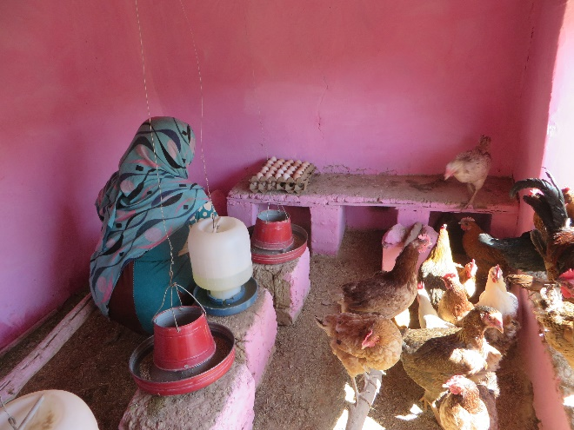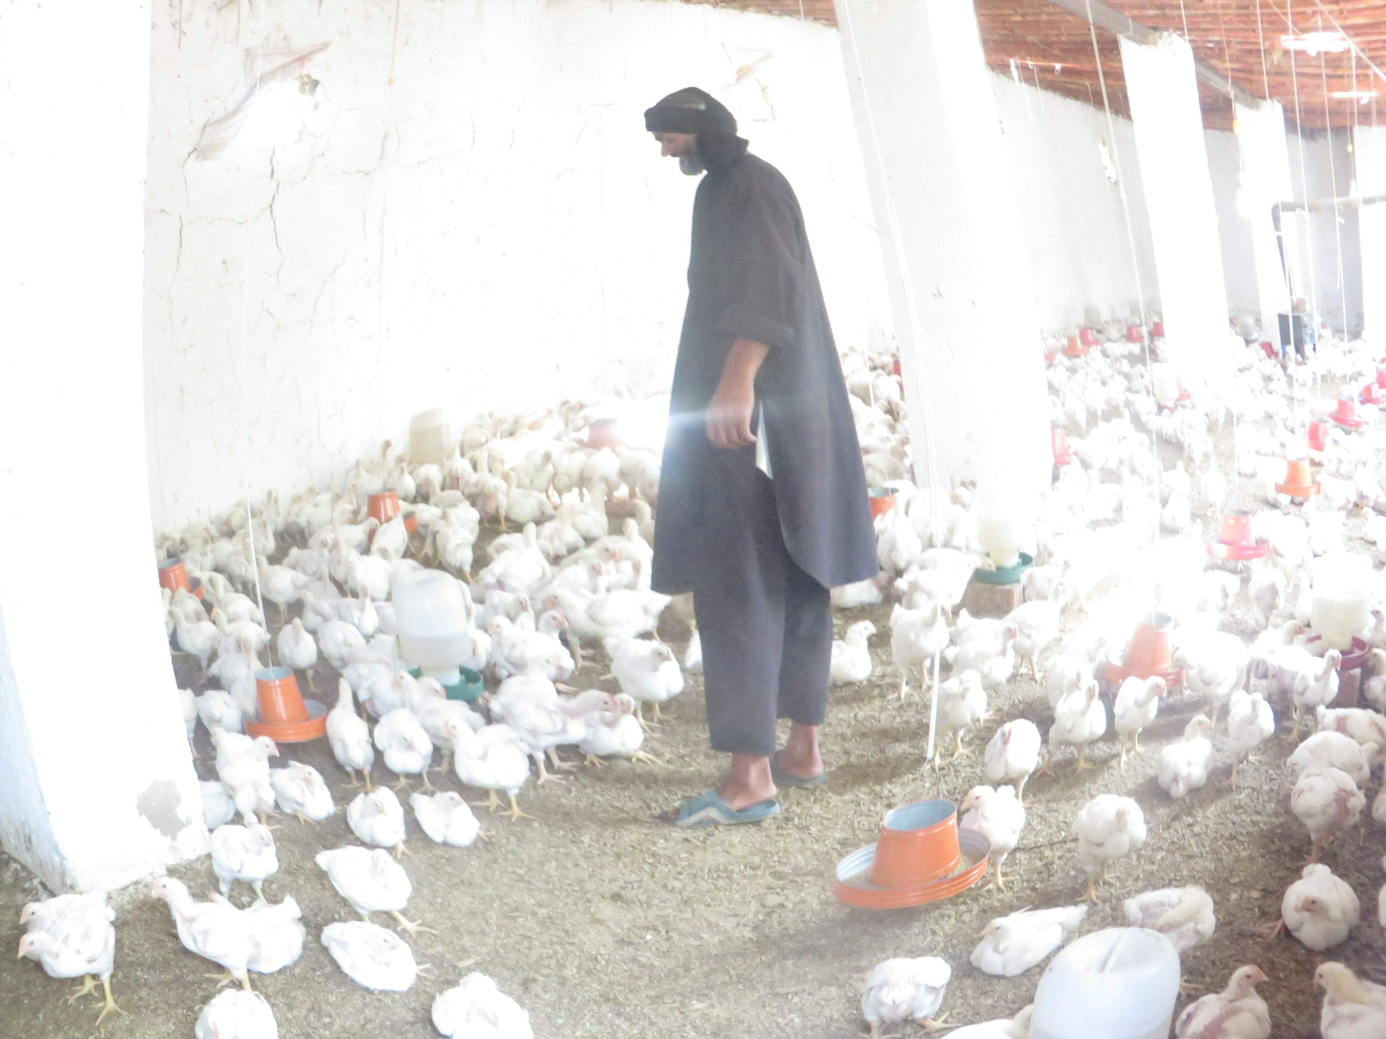
Table 4: Shows the number of egg production, consumption, sells, and income generated in 2018

SN | Province | # of eggs produced | # of eggs consumed at home | # of eggs sold | Total income generated-AFS
1 | Parwan | 229,691 | 31,605 | 198,086 | 1,612,468
2 | Panjshir | 308,563 | 33,035 | 275,528 | 1,968,773
3 | Bamyan | 247,281 | 23,851 | 223,430 | 1,340,580
4 | Maidan Wardak | 214,995 | 29,420 | 185,575 | 1,298,873
Total |  | 1,000,530 | 1,000,530 | 117,911 | 882,619

Table 5: Shows the number of eggs produced, consumption, sales, and income generated in 2019

Sn | Province | # of eggs produced | # of eggs consumed at home | # of eggs sold | Total income generated-AFS
1 | Parwan | 663,242 | 79,469 | 583,169 | 4,831,018
2 | Panjshir | 700,696 | 83,679 | 598,126 | 5,370,624
3 | Bamyan | 780,143 | 63,136 | 728,667 | 5,268,868
4 | Maidan Wardak | 759,119 | 74,731 | 692,223 | 5,311,085
Total |  | 2,903,200 | 2,903,200 | 301,015 | 2,602,185

Table 6: Shows the number of eggs produced, consumption, sales, and income generated in 2020

Sn | Province | # of eggs produced | # of eggs consumed at home | # of eggs sold | Total income generated-AFS
1 | Parwan | 521,563 | 129,962 | 400401 | 3707601
2 | Panjshir | 521,516 | 113,916 | 411105 | 4043120
3 | Bamyan | 1,035,360 | 290,164 | 739196 | 6491714
4 | Maidan Wardak | 536,862 | 179,943 | 353909 | 3328463
5 | Kapisa | 594,825 | 197,701 | 393829 | 3893313
Total |  | 3210126 | 3210126 | 911686 | 2298440

Table 7: Shows the total number of eggs produced, consumption, sales, and income generated

Sn | Province | # of eggs produced | # of eggs consumed at home | # of eggs sold | Total income generated-AFS
1 | Parwan | 1,414,496 | 241,036 | 1,181,656 | 10,151,087
2 | Panjshir | 1,530,775 | 230,630 | 1,284,759 | 11,382,517
3 | Bamyan | 2,062,784 | 377,151 | 1,691,293 | 13,101,162
4 | Maidan Wardak | 1,510,976 | 284,094 | 1,231,707 | 9,938,421
5 | Kapisa | 594,825 | 197,701 | 393,829 | 3,893,313
Total |  | 7,113,856 | 1,330,612 | 5,783,244 | 48,466,500

2.2 Unplanned Results

Unplanned Result | Cause of result
Increase awareness and distribution of COVID -19 hygiene kit to farmers | The activity for the response to the COVID-19 emergency planned under project outputs for the general awareness of people, particularly the BADILL project beneficiaries about COVID-19 that is currently threatening the world, DCA through the BADILL project has always been doing its best possible endeavours to increase/inform the targeted communities about the hazards of this virus. Therefore, considering the outbreak of COVID-19 and the report of confirmed cases from almost all provinces of Afghanistan DCA in consultation and coordination with UNODC/donor on the first of May 2020 commenced the public awareness campaign within the BADILL project targeted provinces including Kabul, Kapisa, Parwan, Panjshir, Wardak and Bamyan. Items including 18,000 bars of soap and 18,000 face masks distributed to 9,000 farming household in the above-mentioned provinces.
Market linkages | As a result of linkages developed from participation in trade fairs/Ag-fairs, farmers/producers were linked with local and regional markets.
Detection of antimicrobial residues in milk | The misuse of and uncontrolled antimicrobial medicine use in animals can have harmful effects on consumer’s health, especially when the withdrawal period is not observed by producers. The presence of antibiotic residues can lead to microbial resistance and public health concern. To understand the current situation in terms of antimicrobial residues in raw milk, experimentally and randomly 170 milk samples were collected from Parwan, Panjshir and Wardak provinces. The rapid enzyme-linked receptor-binding assay test was carried out and the obtained result showed the presence of antibiotics (Tetracyclines and Penicillin) residues in milk, with 16 positive samples (9%). The results indicate that the farmers do not always respect the time between the administration of antibiotics and milk collection, therefore, there should be a monitoring system in place to bring awareness to the livestock farmers/producers and retailers regarding the health hazardous and effects of antimicrobial drug residues and continuous supervision is needed on the use of these drugs to ensure a safe supply of animal based food of good quality, and also the milk containing antibiotic residues should be declared unfit for human consumption.

3. Progress against Implementation Plan attached as an annex

3.1 Progress this quarter

Allocation: 01 December 2017 – 31 December 2020: US$ 1,864,765
Expenditure/Obligations: 01 December 2017 – 30, Nov 2020 US$ 1,814,995

Note: The final financial report and explanation of significant variances will be shared later on

Current Progress (please indicate)
On track
BADILL project implementation is on track to meet the goals set out.

4. Any significant issues, problems or challenges (internal and external) encountered, and action taken or required.

To date BADILL project has had to deal with some challenges, these include:

- Weather-induced challenges: The harsh winter in 2019 affected the distributed pullets particularly in Parwan/Salang and Bamyan provinces. Although few cases of mortality were reported, but, the cold weather put the pullets under extreme stress. Recurrent drought, causing degradation of grazing pastures and lack of fodder affected the body condition and health of livestock. This issue was overcome by the combined interventions of linking beneficiaries with existing Veterinary Field Units (VFUs)/ female basic veterinary workers, the provision of concentrate feed and the establishment of feed banks, training the farmers in silage making and winter feed management for both poultry and dairy.
- Lack of quality inputs: lack and poor quality of inputs for poultry farming has been another major challenge in the targeted areas. With these poor-quality inputs, the beneficiaries would not have been able to achieve the production level of poultry which are achieved at present. DCA has ensured the availability of quality inputs by linking the target farmers with reputable firms in the national and regional markets, use of technical skills in assessing the quality of these inputs and providing training to beneficiaries and local entrepreneurs/ service providers such as MCCs, VUF services including animal health, welfare and breed improvement through Artificial insemination and community-based livestock feed banks, these will enabling them to produce local-based quality feed and availability of diversified services.
- Lack of access to markets: The main challenge for the dairy and egg producers has been lack of access to markets. This has been tackled by developing (gender-sensitive) market chains including the establishment of district-based Milk & Egg Collection Centres (MCCs), where the milk and produced eggs are collected daily, processed, and sold to local, and regional market/customers. By training female basic veterinary workers and providing women with relevant skills, inputs and information it is easier for women to participate in these market chains.
- Security problems: poor security has hampered project implementation in some areas of Maidan Wardak and Parwan in particular women’s participation in the extension groups. Nevertheless, the women-to-women approach has enabled women to be involved in project activities. The project selected local women and trained them to become Basic Veterinary Workers within their own communities. These BVWs play an active role in mobilizing and encouraging other women to participate in project activities. Furthermore, strong coordination with local government helps the project field staff to well manage their movement, and travels to the villages and communities. As an innovative approach community elders and Mullahs travel with the field staff particularly in the most insecure areas to reduce the risk of attacks and increase the level of project intervention acceptance by the respected communities.
- COVID-19: project activities have been affected by COVID-19 pandemic. Afghanistan is rated as very high on the COVID-19 INFORM Index and it has had a devastating impact on people’s livelihoods. In addition to raising community’s awareness on COVID-19 and ways to prevent its spread, project staff adhered to WHO safety guidelines, such as using Personal Protective Equipment (PPE) and exercising social distancing. Project staff worked with individual farmers as much as possible or when working with groups social distancing was practiced.

Lessons learned and suggestions

- BADILL project is now in its third year. The project has managed to support 5,000 people (90% women, 10% men) with improved access to markets, animal healthcare services, inputs and information. This has resulted in increased, and stable incomes from small-scale poultry and dairy businesses. Equally important, the project has contributed to the empowerment, status and self-esteem of women. All the project targets have been reached and the project is highly appreciated within the project communities as demonstrated by several letters of appreciation provided by local government authorities and communities to the BADILL project staff.
- Data on drug use, particularly for the BADILL provinces is largely unavailable but evidence shows that long-term development investment and holistically addressing economic development and social inclusion have resulted in communities rejecting extremist influences as well as illicit livelihood activities,,.
- Women’s economic empowerment is a complex and slow process that requires changes at various levels for it to be sustainable. Poultry production and dairy farming have proven to be viable and relevant income generating opportunities for women as traditionally women have always been involved in animal husbandry. However, for these activities to be viable in the long-term, value chains have to be organized in such a way that these are gender sensitive. This includes the provision of direct women to women extension and training as well as animal healthcare services. Furthermore, inputs for poultry and dairy husbandry need to address women’s specific needs and be suitable for use by women. Developing such gender-sensitive value chains means changing attitudes as these value chains have long been male dominated. Changing attitudes and organizing such gender-sensitive value chains takes time. In order for these changes to take place we propose to extend the BADILL project by 3 years. Through the combined effort of developing productive resources and empowering women we will facilitate the participation of women in these market chains.
- Productive resources include i) assets, and ii) services. More concretely assets refer to the provision of poultry and equipment such as hygiene kits, construction materials, motorbike for the collection and transportation of milk, lactometers, manual dairy products packaging machine, feed, farm equipment etc. In terms of services we will invest in training and equipping additional female basic veterinary workers and female extension workers. Recruiting and training these women and getting consent from male members of the household takes time. In terms of power and agency three elements are of particular relevance to women’s ability to exercise power and agency in agrifood value chains, these are i) capabilities, ii) self-confidence and iii) decision-making power. The BADILL project works on all of these facets through training women on livestock management, healthcare and feeding among others. Self-confidence is gained through increased capacities, the support of male members and their ability to increasingly support their children with their education. An important aspect in this regard is our work on changing norms and attitudes of community members by raising awareness about women’s contribution to food security and the household economy. Decision-making power is gained through ensuring that women can keep the money they earn and decide what to do with it. This is explicitly negotiated between the project staff and male members of the household. At present we already see the results of this increased decision-making power as some women are expanding their income-generating activities or venturing into other activities.
- To exploit the initial success of the project and build upon the momentum created by, a) intensifying and follow up work in the current BADILL communities and b) expanding to areas where poppy cultivation and addiction to narcotics has taken root. Currently the project reaches about 5% of the total number of communities in the project provinces. At the same time farmers in the same communities have been encouraged by the project results and have requested to be included in the project. Including more households and communities in the project creates critical mass. Critical mass is explained as a sufficient number of adopters of a new idea, technology or innovation in a social system so that the rate of adoption becomes self-sustaining and creates further (economic) growth. For example, in gender politics this number has been placed at 30%, before women are able to make a substantial difference in politics. Likewise, at community level it is important to involve enough people in order to meaningfully change practices, perceptions and behaviour. Involving a larger share of the community will strengthen the resilience against shocks such as COVID-19 but also provide a buffer against the temptation of getting involved in poppy cultivation and/or drug use. Involving more communities and expanding to other districts and provinces will furthermore strengthen the market chains and accelerate economic growth within these communities by generating employment and providing quality products that are in high demand.
- A rapid COVID-19 assessment covering 18 provinces of Afghanistan indicated that 80% of women (compared to only 22% men) had not received any information about COVID-19. Given women’s key role in assuring household hygiene and children’s health it is of vital importance that women receive timely information about COVID-19 and other One Health issues. DCA has been rapid to respond by mobilizing the VFU/BVW network in delivering public awareness campaigns on COVID-19. In addition to the distribution of basic hygiene kits (PPE), and leaflets among the communities. Particular attention was given to raising awareness about the importance of preventive measures such as proper hand washing and social distancing.
- The poultry and dairy package include development of a gender-sensitive value chain and integrating the beneficiaries within this chain through input distribution, linking to female BVWs and VFUs, providing access to markets and women-to-women extension and training. Some of the lead farmers have shown great ability and motivation to expand their businesses, therefore, there will be a need to consider supporting these farmers with the transition from a backyard poultry system to a semi-commercial system. The pullets for distribution and replacement have had to be imported from Pakistan. This is costly and the long travel affects the condition and health of the pullets. Furthermore, these pullets are not always available. To ensure a constant supply of healthy (vaccinated) pullets especially for replacement purposes by the local farmers and communities we therefore propose setting up local hatcheries at selected locations. These hatcheries contribute to diversifying income and providing jobs. For the sustainability purposes in the future, we will consider lamb fattening (meat), and dry yogurt value chain introduction particularly in mountainous, and cold areas where conditions for poultry production in comparison to small ruminants are suboptimal. DCA has extensive experience supporting women with setting up their small-scale business in lamb fattening which has proven to be a profitable and self-sustaining income generating activity after initial input, service and extension support. This package, like the dairy and poultry package, will include technical training on sheep management, health and feeding in addition to providing linkages to animal health services and access to markets.

Continued relevance or proposed course-corrections:

The sub-program is also aligned with the 2030 Agenda for Sustainable Development. The program will actively contribute to Sustainable Development Goals (SDG 2, 8 and 12). In addition, it will also contribute to the UNDAF Pillar-1 Economic Development and the UNODC Country and Regional Programme.

Conclusion

The UNODC-founded “Boost Alternative Development Intervention through Licit Livelihoods (BADILL)” aims to provide viable economic alternatives to reduce the social and economic vulnerability of rural communities suffering conflict and ongoing insecurity associated with the narcotics economy in Afghanistan.
During the reporting period, DCA expanded and intensified BADILL project in Kabul, Kapisa, Parwan, Panjshir, Wardak, and Bamyan provinces contributing to increasing the capacity of local farmers and entrepreneurs to resource, implement and sustain a range of community-based development and initiatives and increasing the range of licit income generating opportunities for women and men in target areas. Capacity building of farmers and local entrepreneurs has led to a number of market-oriented community enterprises resulting in direct economic and social benefits for villagers. To ensure gender-based interventions a number of livelihoods activities such as backyard poultry farms and dairy enterprises successfully targeted women. Support to veterinary service providers and FBVWs resulted in a number of immediate gains for communities including improved access to quality veterinary services which has improved the health and productivity of livestock. This is reflected by the decrease in infectious disease prevalence as reported by the VFUs. As a result of improvement in animal welfare and with knowledge and skills in communities, an increasing number of households invest in dairy animals and backyard poultry farms. Community-based livestock feed banks, establishment of milk and egg collection centres, support to local enterprises and entrepreneurship, raising community awareness on harmful practice of poppy cultivation and drug addiction, extension training has been intensified and helped further diversify livelihood opportunities.

It is an estimation. Every Household on average has 7 members. Of the 5000 direct beneficiaries, 1 member of HH is direct beneficiary the remaining 6 member is considered as indirect. 5000 multiplied by 6 is 30,000.
Baseline data in not available but field observation and farmer’s interview revealed that the project intervention positively affected the production and income level of the benefited households.
https://www.devex.com/news/sponsored/opinion-breaking-the-vicious-circle-of-hunger-and-conflict-98952
https://jied.lse.ac.uk/articles/10.31389/jied.17/
SIGAR (2018) Counternarcotics: Lessons from the U.S. experience in Afghanistan. Special Inspector General for Afghanistan Reconstruction. Virginia, U.S.A. p.270

